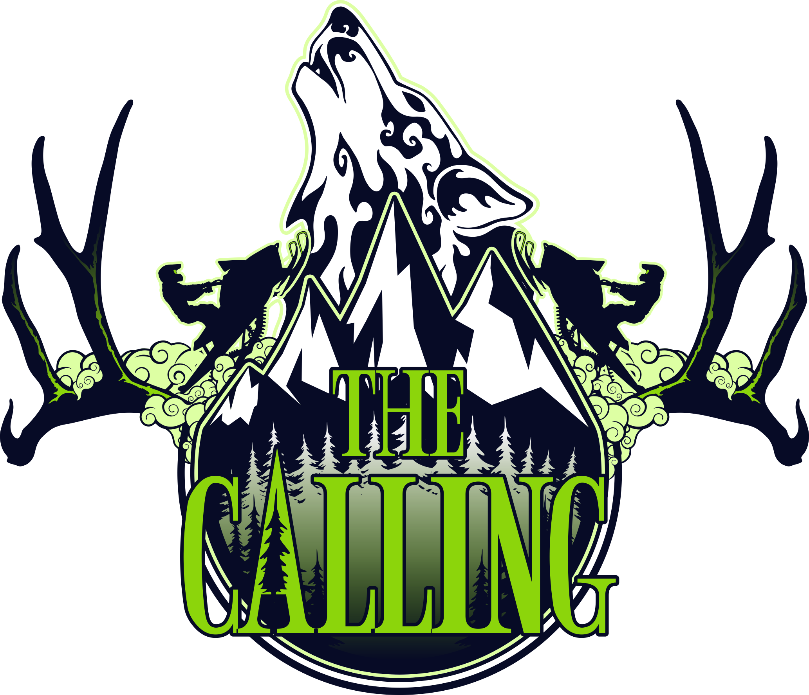

CROSS COUNTRY RACE DIRECTOR

THE CALLING 2018

A MOUNTAIN SNOWMOBILE FESTIVAL and NON-PROFIT FUNDRAISER

|  |  |  |
| --- | --- | --- |
| SKADI Foundation Box 362 Revelstoke BC V0E 2S0 |  | skadifoundation@gmail.com  http://www.skadifoundation.com |

Table of Contents

1. The Calling Profile 2

Mission Statement

Objectives

Organizational Chart

1. Activity Profile 4
2. Director Roles and Responsibilities 4
3. Contacts Sheet 5
4. Timeline and Activity Schedules 6
5. Budget 11
6. Marketing 12
7. Legal and Liability Management 13
8. Policies 14

Code of Conduct

Policies in Review

1. Risk Management 15
2. Site Plan 17
3. Equipment 19
4. Contractors 19
5. Volunteers 20
6. Sponsors 21
7. Stakeholders and Community Resources 21
8. Additional Notes 21

# The Calling Profile

## Mission Statement

*The Calling* is an annual snowmobiling festival in Revelstoke, British Columbia that generates funding for non-profit groups, shifts the culture of safe backcountry mountain motorized use practices, generates community revenue and exposure for Revelstoke as a world-class snowmobiling destination.

## Objectives

The objectives of *The Calling* are as follows:

* Establish an annual snowmobiling festival in Revelstoke, BC specific to the winter sport community that includes a prestigious Cross Country Snowmobiling Race, Vendor Village, Freestyle Demonstrations, Education Clinics and Entertainment.
* Devise a strict Risk Management Plan that includes an effective Emergency Response Plan; these plans should set a new precedence in the industry and be used as a legacy for succeeding winter sport events.
* Raise funds for local non-profits.
* Provide educational opportunities that direct a shift in the culture of safe backcountry mountain motorized use practices.
* Work with local volunteers and clubs to achieve an inclusive community event.
* Use community resources wherever possible to generate community revenue.
* Cross-market Revelstoke, British Columbia and Canada as a world-class snowmobiling destination.
* Maximize marketing opportunities for sponsors and stakeholders.

## Organizational Chart

Attached Organization Chart.



# Activity Profile

The Cross Country Race is *The Calling’s* flagship event. The Cross Country Race is an exclusive, high profile, competitor invite only event with the biggest cash haul in snowmobiling to attract the biggest names in the industry. Ten teams (two wild cards) of two are awarded the opportunity to compete in the race. To achieve a coveted spot in the race competitors must submit a video application describing their desire, merit and skill. Applications are open to Snowmobilers and Snowbikers. Applications are evaluated based on pre-set guidelines and awarded accordingly. The race starts in the Eagle Pass cabin, weaves through approximately 80 km of Monashee Mountain Range and finishes in the Boulder Mountain cabin.

# Director Roles and Responsibilities

The Director works directly with the Festival Coordinator. The following is a summary of the Director’s responsibilities:

* Design a proposal that meets the requirements outlined in the Activity Profile and follows *The Calling’s* objectives and Director Package Template.
* The Director of the winning proposal must make any changes required by the Boards in accordance with their contract and resubmit their package for final approval. The Festival Coordinator is then responsible for forwarding the approved package to the Executive Administration Assistant and relevant Coordinators indicated in each section of the package.
* Ensure the Festival Coordinator, Executive Administrative Assistant and relevant Coordinators indicated in each section of the package are immediately notified regarding changes to the package leading up to the festival and during the festival.
* Submit detailed schedules for all persons involved with their Activity.
* The Director is required to attend the daily Morning Safety/Operations Meetings and Safety/Operations Debrief Meetings during the festival.
* Provide a general budget for their Activity.
* Work within the Legal and Liability Management outline provided by *The Calling* and provide insight on potential Legal and Liability Management issues within their Directorship.
* Submit the Risk Assessment Package for their Activity and work within the Risk Management outline provided by the Backcountry Safety Coordinator.
* Appoint a designated emergency response lead at the site of their Activity who in the event of an Emergency follows the steps outlined in the Emergency Procedures Insert at the front of the final Director Package.
* The Director must contract, supply and is responsible for equipment required to conduct their Activity.
* The Director must hire and is responsible for sub-contractors required to conduct their Activity.
* Collect and provide feedback for Festival Debrief Meeting.
* The Director must ensure their Activity is conducted in compliance with *The Calling’s* Code of Conduct and Policies*.*

# Contacts Sheet

The Director must submit a Contacts Sheet for persons involved in their Activity. The Festival Coordinator, Executive Administration Assistant and the Backcountry Safety Coordinator must be notified immediately if changes are made to the Contacts Sheet.

|  |  |  |  |
| --- | --- | --- | --- |
| **CROSS COUNTRY RACE DIRECTOR**  **CONTACTS SHEET** | | | |
| **Name** | **Role** | **Email** | **Phone** |
| (enter later) | Executive Administrative Assistant | (enter later) | (enter later) |
|  | Festival Coordinator |  |  |
|  | Cross Country Race Director |  |  |
|  | Freeride Competition Director |  |  |
|  | Avalanche Awareness and Riding Clinics Director |  |  |
|  | Photo and Video Challenges Director |  |  |
|  | Social Events Coordinator |  |  |
|  | Marketing Coordinator |  |  |
|  | Communications Director |  |  |
|  | Merchandise Director |  |  |
|  | Website Director |  |  |
|  | Social Media Director |  |  |
|  | Media Production Coordinator |  |  |
|  | Base Camp Media Production Director |  |  |
|  | Backcountry Media Production Director |  |  |
|  | Freeride Competition Media Production Coordinator |  |  |
|  | Base Camp Coordinator |  |  |
|  | Base Camp Safety Coordinator |  |  |
|  | Backcountry Safety Coordinator |  |  |
|  | Volunteers Coordinator |  |  |
|  |  |  |  |
|  | (Additional contacts may be entered later) |  |  |
|  | Contractor |  |  |
|  |  |  |  |
|  |  |  |  |
|  |  |  |  |
|  |  |  |  |
|  |  |  |  |

# Timeline and Activity Schedules

The Director must submit schedules for all persons involved in their Activity. The Festival Coordinator, Backcountry Safety Coordinator, Executive Administrative Assistant and Marketing Coordinator (relevant information) must be notified immediately if changes are made to the timeline and schedules.

|  |  |  |
| --- | --- | --- |
| **THE CALLING 2018 PROJECT**  **DEVELOPMENT/IMPLEMENTATION TIMELINE**  **2017-2018** | | |
| 2017  Project Development  Budgets  Fundraising  Communications  Scheduling  Implementation  Monitoring  Problem Management | | * May-Sep: PHASE 1 – BUDGET DEVELOPMENT * Complete Draft 3 of Operations and Business Plans * Coordinators/Directors submit proposals; upon acceptance revisions required by Board * Fill all positions * Definitive Budgets (+10% to -10% accuracy) * Finalize Coordinator/Director Packages * Jul-Sep: PHASE 2 – FUNDRAISING STRATEGY * Team Meeting * Fundraising Strategies Brainstorm Session * Team Resources and Skills Assessment * Establish Sponsorship Structure/The Calling 2018 Branding * Media Development for fundraising strategies * Strategy Launches * Jul-Sep: PHASE 3 – COMMUNICATIONS * Team Communication Strategies/Templates * Stakeholder Communication Strategies/Templates * Media Communication Strategies/Templates * Jul-Sep: PHASE 4 – SCHEDULING * Work Breakdown Structures, GANTT Charts, Milestones Chart (visually easy to follow) * Deadlines, follow-up, accountability, monitoring * Status Updates and Status Reports * Sep-Dec: PHASE 5 – IMPLEMENTATION * Deposits to Coordinators/Directors * Booking * Permits/Government Approvals * Public Consultations * Vital Services Meetings * Policy Development * Launch Marketing Strategy * Sep-Dec: PHASE 6 – MONITORING * Follow-up * Team and Stakeholder Communications * Sep-Dec: PHASE 7 – PROBLEM MANAGEMENT * Assist team with staying on track |
| 2018  Implementation  Monitoring  Problem Management  Closing | | * Jan-Mar: PHASES 5-7 * Jan: Confirm contractors and rentals * Feb: Plan review and last-minute corrections * Mar: Festival set-up and take-down * Mar-Apr: PHASE 8 – CLOSING * Apr: Appreciation to Volunteers, Stakeholders, The Calling Members and Contractors * Apr: Festival Debrief and develop The Calling 2019 Plan * May: Present The Calling 2019 Plan to Stakeholders |
| **CROSS COUNTRY RACE DIRECTOR**  **DEVELOPMENT/IMPLEMENTATION TIMELINE**  **2017-2018** | | |
| Activities that need to be included in Timeline | * Work with Exec Admin Team on Policy Development * Meet with Backcountry Safety Coordinator to develop Risk Management Plan * Work with Backcountry Safety Coordinator to establish clearly defined routes, develop maps (design, layout), safety team requirements, barrier and pylon requirements * Submit backcountry safety equipment (avalanche transceiver, probe, shovel, airbag) request to Backcountry Safety Coordinator * Submit Volunteers Request to Volunteers Coordinator * Submit safety gear, radios, barriers and pylons request to Base Camp Safety Coordinator * Meet with Marketing Coordinator to develop/pick-up/distribute marketing content * (advertising posters/newspapers/radio ads not required – this event will be advertised in the overall The Calling 2018 campaign) badges and identifiers, swag bag, signage (routes, event indicator, crowd control, traffic control), sponsor banners, novelty cheques, Cross Country Race Poker Cards, Participant Recruitment, Invite and Accepted Packages, participant jerseys, custom webpage (updates/real-time tracking, feed, racer profiles, blog from teams, schedule, post-event results, schedule and location changes), working group webpage (schedules for volunteers, vested parties), social media ads (schedule and location changes, participant profiles, race updates, post-event info). * Develop Terms and Conditions for competition (review Competition Act and relevant Criminal Code Guidelines) * Work with Revelstoke Snowmobile Club to establish parking plans, land use agreement, waste management * Meet with Eagle Valley Snowmobile Club to establish parking plans, land use agreement, waste management * Apply for Land Use and Event Permits * Discuss Application Fees and Deposit collection with Exec Admin * Design and purchase trophy * Book tents: start (2) and finish (2) lines * Meet with Media Production Coordinator/Backcountry Media Production Director to discuss routes and boundaries * Work with Base Camp Coordinator to establish Racer Pits at Base Camp * Select Judges (ask Admin to assist with formal letter), Board Approval * Book a shuttle or other method for participants to get from finish line back to start line | |
| 2017 | * Aug * Submit Proposal, complete required adjustments * Sep * Attend Fundraiser Meeting * Oct * Nov * Marketing Coordinator to launch participant recruitment campaign * Dec * Marketing Coordinator to close participant recruitment campaign * Participant selection process, Marketing Coordinator to mail-out invite packages | |
| 2018 | * Jan * Confirm contractors and rentals * Marketing Coordinator to mail-out accepted participant packages * Provide Social Media Director and Website Director with participant profiles * Assist Marketing Coordinator with arranging participant radio interviews * Feb * Plan review and last-minute corrections * Mar * Conduct Volunteer Briefing Meeting with volunteers scheduled to work within your Directorship * Collect/distribute badges and identifiers from Marketing Coordinator * Collect and distribute safety gear and radios from Base Camp Safety Coordinator * Collect and distribute avalanche safety equipment from Backcountry Safety Coordinator * Apr * Collect Feedback * Collect/return safety gear and radios to Base Camp Safety Coordinator * Collect/return avalanche safety equipment to Backcountry Safety Coordinator * Attend Festival Debriefing Meeting | |
| As at XXX, 2017 | | |

|  |  |
| --- | --- |
| **DAILY CROSS COUNTRY RACE SCHEDULE**  **DIRECTOR**  **March 29 – April 2, 2018** | |
| Thursday,  March 29 | * 1:00pm - 2:00pm: *The Calling* Members Meeting * 6:00pm - 7:00pm: Participant Meeting |
| Friday, March 30  STAT | * 7:00am - 8:00am: Festival Safety Meeting * 8:00am - 10:00am: Festival Operations Meeting (8-9) and Free Breakfast * 10:00am - 5:00pm: Cross Country Race * 5:00pm - 6:00pm: Opening Ceremony * 6:00pm - 7:00pm: Festival Recap * 6:00pm - 7:00pm: Rider Introductions and Meet and Greet * 7:00pm - 8:00pm: Safety/Operations Debrief Meeting |
| Saturday, March 31 | * 7:00am - 8:00am: Festival Safety Meeting * 8:00am - 10:00am: Festival Operations Meeting (8-9) and Free Breakfast * 10:00am - 5:00pm: Cross Country Race * 6:00pm - 7:00pm: Festival Recap * 7:00pm - 8:00pm: Safety/Operations Debrief Meeting |
| Sunday, April 1 | * 7:00am - 8:00am: Festival Safety Meeting * 8:00am - 10:00am: Festival Operations Meeting (8-9) and Free Breakfast * 10:00am - 5:00pm: Cross Country Race * 5:00pm - 6:00pm: Closing Ceremony and Awards * 6:00pm - 7:00pm: Festival Recap * 7:00pm - 8:00pm: Safety/Operations Debrief Meeting |
| Monday, April 2 | * 8:00am - 9:00am: *The Calling* Members and Stakeholders Meeting * 9:00am - 10:00am: Participant Meeting |
| As at XXX, 2017 | |

|  |  |
| --- | --- |
| **DAILY CROSS COUNTRY RACE SCHEDULE**  **VOLUNTEER**  **March 30 – April 1, 2018** | |
| Friday, March 30  STAT | * 7:00am - 8:00am: Festival Safety Meeting * 8:00am - 10:00am: Festival Operations Meeting (8-9) and Free Breakfast * 7:00pm - 8:00pm: Safety/Operations Debrief Meeting |
| Saturday, March 31 | * 7:00am - 8:00am: Festival Safety Meeting * 8:00am - 10:00am: Festival Operations Meeting (8-9) and Free Breakfast * 7:00pm - 8:00pm: Safety/Operations Debrief Meeting |
| Sunday, April 1 | * 7:00am - 8:00am: Festival Safety Meeting * 8:00am - 10:00am: Festival Operations Meeting (8-9) and Free Breakfast * 7:00pm - 8:00pm: Safety/Operations Debrief Meeting |
| As at XXX, 2017 | |

|  |  |
| --- | --- |
| **DAILY CROSS COUNTRY RACE SCHEDULE**  **CONTRACTOR**  **March 30 – April 1, 2018** | |
| Friday, March 30  STAT | * 7:00am - 8:00am: xxx |
| Saturday, March 31 | * 7:00am - 8:00am: xxx |
| Sunday, April 1 | * 7:00am - 8:00am: xxx |
| As at XXX, 2017 | |

|  |  |
| --- | --- |
| **DAILY CROSS COUNTRY RACE SCHEDULE**  **PARTICIPANT**  **March 29 – April 1, 2018** | |
| Thursday,  March 29 | * 6:00pm - 7:00pm: Participant meeting |
| Friday,  Mach 30  Bad Weather: Race Schedule to Saturday | * 7:00am - 8:00am: Festival Safety Meeting * 8:00am - 10:00am: Free Breakfast * 10:00am: Release Participant 1 * 10:30am: Release Participant 2 * 11:00am: Release Participant 3 * 11:30am: Release Participant 4 * 1:00pm: Anticipated return of Participant 1 * 1:30pm: Anticipated return of Participant 2 * 2:00pm: Anticipated return of Participant 3 * 2:30pm: Anticipated return of Participant 4 * 2:30pm - 5:00pm: Return of Participants wiggle room * 5:00pm - 6:00pm: Opening Ceremony * 6:00pm - 7:00pm: Festival Recap * 6:00pm - 7:00pm: Rider Introductions and Meet and Greet * 7:00pm - 8:00pm: Safety/Operations Debrief Meeting |
| Saturday,  March 31  Bad Weather: Race Schedule to Sunday | * Friday riding schedule if weather was unstable * 7:00am - 8:00am: Festival Safety Meeting * 8:00am - 10:00am: Free Breakfast * 10:00am: Release Participant 5 * 10:30am: Release Participant 6 * 11:00am: Release Participant 7 * 11:30am: Release Participant 8 * 1:00pm: Anticipated return of Participant 5 * 1:30pm: Anticipated return of Participant 6 * 2:00pm: Anticipated return of Participant 7 * 2:30pm: Anticipated return of Participant 8 * 2:30pm - 5:00pm: Return of Participants wiggle room * 6:00pm - 7:00pm: Festival Recap * 7:00pm - 8:00pm: Safety/Operations Debrief Meeting |
| Sunday,  April 1 | * Saturday riding schedule if weather was unstable * 5:00pm - 6:00pm: Closing Ceremony and Awards * 6:00pm - 7:00pm: Festival Recap |
| Monday,  April 2 | * 9:00am - 10:00am: Participant Meeting |
| As at XXX, 2017 | |

# Budget

The budget of $XX,XXX has been allocated to this Directorship. The Director must provide a general breakdown of projected expenses for the Activity. Include in-kinds and potential receivables.

The budget in this Directorship may include: Director salary, 4 10x10 tent rentals (start (2) and finish (2) lines), satellite phones, GPS Communicators, prize money ($20,000), trophy, clipboards, food/water at way-points, timing equipment, shuttle for participants to get from finish line back to start line.

Items supplied by other areas of responsibility include: marketing materials indicated in Marketing section supplied by Marketing Coordinator; safety gear, radios, barriers and pylons supplied by Base Camp Safety Coordinator; Safety Team supplied by Backcountry Safety Coordinator; Swag Bag contents supplied by Base Camp Coordinator; spare backcountry safety equipment (avalanche transceiver, probe, shovel, airbag) for working groups and participants supplied by the Backcountry Safety Coordinator.

Potential Receivables in this Directorship may include: Participant Application Fees.

# Marketing

Marketing for this Directorship is supplied by the Marketing Coordinator. Items in the Marketing Plan specific to this Directorship include: (advertising posters/newspapers/radio ads not required – this event will be advertised in the overall The Calling 2018 campaign) badges and identifiers, swag bag, signage (routes, event indicator, crowd control, traffic control), sponsor banners, novelty cheques, Cross Country Race Poker Cards, Participant Recruitment, Invite and Accepted Packages, participant jerseys, custom webpage (updates/real-time tracking, feed, racer profiles, blog from teams, schedule, post-event results, schedule and location changes), working group webpage (schedules for volunteers, vested parties), social media ads (schedule and location changes, participant profiles, race updates, post-event info).

The Director must submit a request for marketing materials, provide content, and notify the Marketing Coordinator of any incorrect or updated information for the website and social media regarding their Directorship.

It is an objective of *The Calling* to maximize marketing opportunities for sponsors and stakeholders. The Director must provide insight to and submit requests to the Marketing Coordinator for marketing opportunities within their Directorship for example: promotions, cross-marketing and merchandise.

# Legal and Liability Management

The Director must work within the Legal and Liability Management outline provided by *The Calling.* The Director must provide insight on potential Legal and Liability Management issues within their Directorship.

Potential Legal and Liability Management within this Directorship include:

* Role Contract
* Collect required copies for due diligence: waivers (participant, sub-contractors, volunteers), contracts, certificates, permits, licenses, sub-contractor WCB clearance letters
* Event Permit
* Radio Use Permit
* Land Use Requirements
* Liability Insurance
* Policy Development: race rules (Terms and Conditions), discipline, skill requirements (participant and volunteers), confidentiality (participant and volunteers), Bad Weather, Injured Participant, Medical Policy for the Removal of Athletes from Competition, Wildcards, Spectator

# Policies

## Code of Conduct

Members of *The Calling*, Contractors and Volunteers actively representing *The Calling* must behave in a professional, safe manner and act in the best interest of *The Calling*. Alcohol consumption and drug use is detrimental to *The Calling’s* vision of providing a safe, community event and is not acceptable.

## Policies in Review

The following policies are in review for this Directorship: race rules (Terms and Conditions), discipline, skill requirements (participant and volunteers), confidentiality (participant and volunteers), Bad Weather, Injured Participant, Medical Policy for the Removal of Athletes from Competition, Wildcards, Spectator

# Risk Management

It is an objective of *The Calling* to devise a thorough Risk Management Plan that includes an effective Emergency Response Plan. Risk Assessment Packages assist Safety Coordinators in the development of Risk Management Plans and ensure Vital Service requirements are in place at each Activity. The following plans are explored in the Risk Assessment Package: Master Site Plan, Medical Plan, Security Plan, Public Health Plan, Fire Safety Plan, Communications Plan, Traffic Management Plan, Liquor Control Plan, Other Contingency Plans.

The Backcountry Safety Coordinator will assist with developing and finalizing the Risk Assessment Package for this Directorship. The Director must work within the finalized Risk Management Plan provided by the Backcountry Safety Coordinator. The Director must appoint a designated emergency response lead at the site of the Activity who in the event of an emergency follows the steps outlined in the Emergency Procedures Insert (provided by the Backcountry Safety Coordinator) at the front of the final Director Package. The Festival Coordinator, Backcountry Safety Coordinator and the Executive Administration Assistant must be notified immediately if changes are made to the Risk Management Plan.

The following planning considerations will be reviewed in the Risk Assessment Package for this Directorship:

### Medical Plan

medical personnel, equipment and sources, medical personnel schedules, transportation plan (emergency and non-emergency), medical team communications, incident documentation plan, insurance for medical team

### Security Plan

security risk assessment, security team lead, personnel deployment schedule and locations, on-site protocol, emergency security protocol risk assessment/contingencies, communications protocol (on-site and off-site), incident documentation, insurance for security team

### Public Health Plan

waste management, site clean-up

### Fire Safety Plan

complete risk assessment result will be - Not Applicable in this Directorship

### Communications Plan

designated communications lead, communication devices, media access arrangements, pre-scripted messages for delay/cancellation/evacuation, spectator/volunteer/contractor/participant messaging, event safety messages

### Traffic Management Plan

emergency response route protocol, route signage, parking arrangements

### Other Contingency Plans

weather, evacuation plan, delay/cancellation protocol, emergency response protocol, missing persons

Additional Risk Management within this Directorship include: Director must attend Morning Safety/Operations Meetings and evening Safety/Operations Debrief Meetings, Participants must attend Morning Safety and Safety/Operations Debrief Meetings, constant contact with Cross Country Race Safety Team, timed interval check-in log, Cross Country Race Safety Team to respond in the event of an Emergency, spectator management.

Vital Services that may need to be consulted outside of the generic Risk Management Plan for the Cross Country Race may include: Search and Rescue, Local Authority: Parks and Recreation, Conservation Officer and Environment Canada.

# Site Plan

The location for the Cross Country Race is pre-determined by *The* Calling. The proposed location for the Cross Country Race is in the Monashee Mountain Range starting from the Eagle Pass cabin and ending in the Boulder Mountain cabin. The Director must provide a detailed Site Plan which includes the following: Access/Exit Routes, Parking Plan, Vender/Supplier Areas, Staging Area, Start/Finish Area, Routes, Perimeter, Staff/VIP/Media Areas, Medical Layout, Security Layout, Waste Management areas.

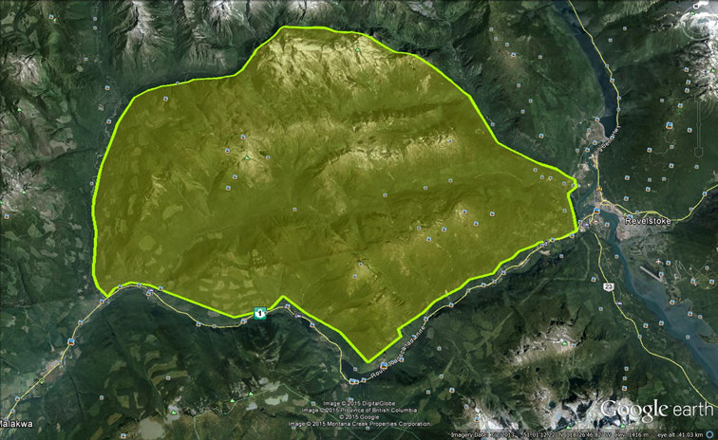

Proposed Racing Area

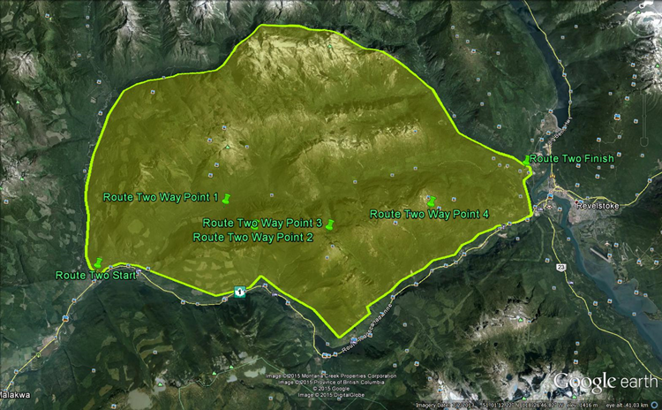

Simple Avalanche Terrain Route 2 Way Points

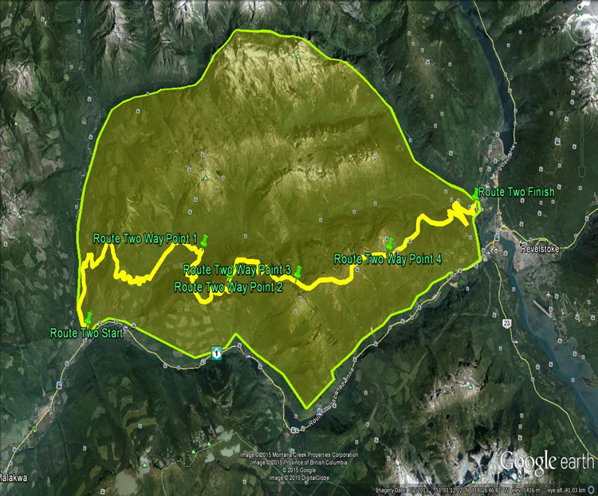

Simple Avalanche Terrain Route 2

(potential route racers would take)

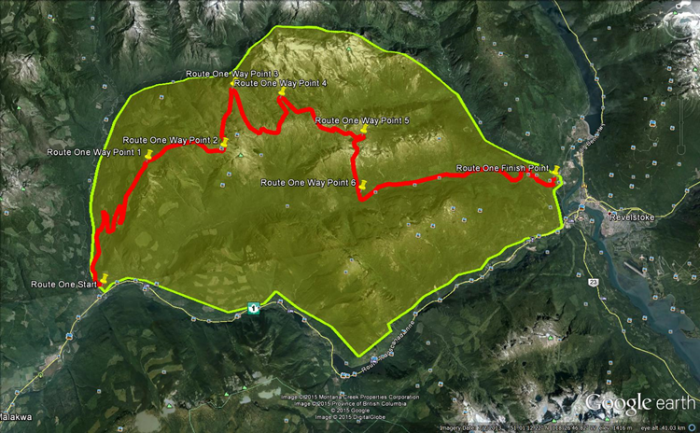

Simple/Challenging/Complex Avalanche Terrain Route

(potential route racers would take)

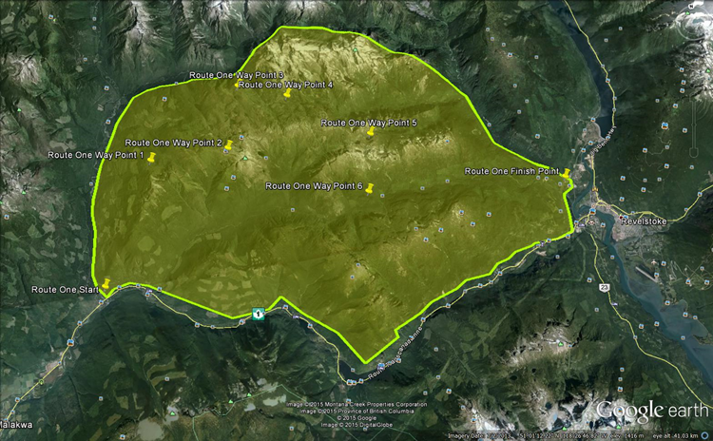

Simple/Challenging/Complex Avalanche Terrain Route 1 Way Point

{INSERT MAPS HERE}

# Equipment

It is an objective of *The Calling* to use community resources wherever possible to generate community revenue. The Director must contract, supply and are responsible for equipment needed to conduct their Activity. The cost for equipment is outlined in the budget.

Equipment required in this Directorship may include: staging tent rentals, satellite phones, and GPS Communicators, timing equipment.

# Contractors

It is an objective of *The Calling* to use community resources wherever possible to generate community revenue. The Director is responsible for hiring Contractors. Contractors hired must be in good standing with WCB. The Director must collect insurance, waivers and other pertinent documents from their Contractors and submit copies to the Festival Coordinator for proof of due diligence. A list of potential/confirmed Contractors should be provided here.

Contractors required in this Directorship may include: Trophy Artist

# Volunteers

It is an objective of *The Calling* to achieve an inclusive community event; Directors are encouraged to access volunteers and community groups wherever possible. Directors must submit a Request for Volunteers to the Volunteers Coordinator and include the information sampled in table below. For liability and security purposes all volunteers must be registered by the Volunteers Coordinator.

The Volunteers Coordinator recruits and schedules volunteers, ensures relevant waivers and Criminal Record Checks are completed, and collects copies of required certifications and licenses. Volunteers must not be given money or gift certificates for their services. The Director may contact the Volunteers Coordinator if a scheduled volunteer does not show up for their shift.

A list of potential/confirmed Volunteer opportunities should be provided here.

|  |  |  |  |
| --- | --- | --- | --- |
| **REQUEST FOR VOLUNTEERS** | | | |
|  | **General Job Description** | **Requirements** | **Safety Gear/**  **Certificates/Licenses** |
| **Cross Country Race** |  |  |  |
| Staging Area Assistant (2) | Help outfit and organize participants | {What days/hours?} | Vests |
|  |  |  |  |

Volunteer opportunities for this Directorship may include: guest/participant services, staging area volunteer to assist with outfitting and organizing groups, old school and GPS Communicator timers, security volunteers to watch participant equipment (snowmobiles, trucks, gear), judges, sled inspector, way-point teams (first-aid/avalanche trained).

Volunteers to be requested by Backcountry Safety Coordinator may include: members of the Cross Country Race Safety Team

# Sponsors

It is an objective of *The Calling* to maximize marketing opportunities for sponsors and stakeholders. The Director must provide a list of sponsor marketing opportunities within their Activity.

Sponsor Opportunities for this Directorship may include: satellite phone, avalanche transceiver, apps, energy drinks, energy bars, safety gear, apparel, prize sponsor, sled manufacturer, snowbike manufacturer, tourism. Sponsors advertised via flags at start and finish lines, logos on participant jerseys, logos placed on media production during event and at festival recaps/awards, webpage banners.

# Stakeholders and Community Resources

The Director must provide a list of stakeholders and organizations that may be effected by or could provide insight to their Activity and may need to be solicited.

Stakeholders that may be effected by this Activity may include: Avalanche Canada, Eagles Pass Heli Skiing and Boarding, Local CAA Professional Members, Search and Rescue, Eagle Valley Snowmobile Club, Revelstoke Snowmobiling Club, Ministry of Forests, British Columbia Snowmobile Federation, Columbia Shuswap Regional District, City of Revelstoke, First Nations.

# Additional Notes

**© 2017 SKADI Foundation ALL RIGHTS RESERVED**

Plans contained in this document are owned and protected by SKADI Foundation. No part may be reproduced in the development of a similar event without prior written permission from SKADI Foundation. No part of this work may be reproduced or used in any form or by any means – graphic, electronic, or mechanical, including photocopying, recording, taping, or information storage and retrieval systems – without prior written permission from SKADI Foundation.

SKADI Foundation

Box 362

Revelstoke BC V0E 2S0

skadifoudation@gmail.com

http://www.skadifoundation.com

Writer: Jeremy Hanke

Writer/Editor: Misty Bergquist

Contributors: Craig Moore, Duncan Lee, Emily Roberts, Erik Luzak, Jaclyn Moore, Jeff Scott, Mark Karlstrom,

Robert Sim, Scott Wickson