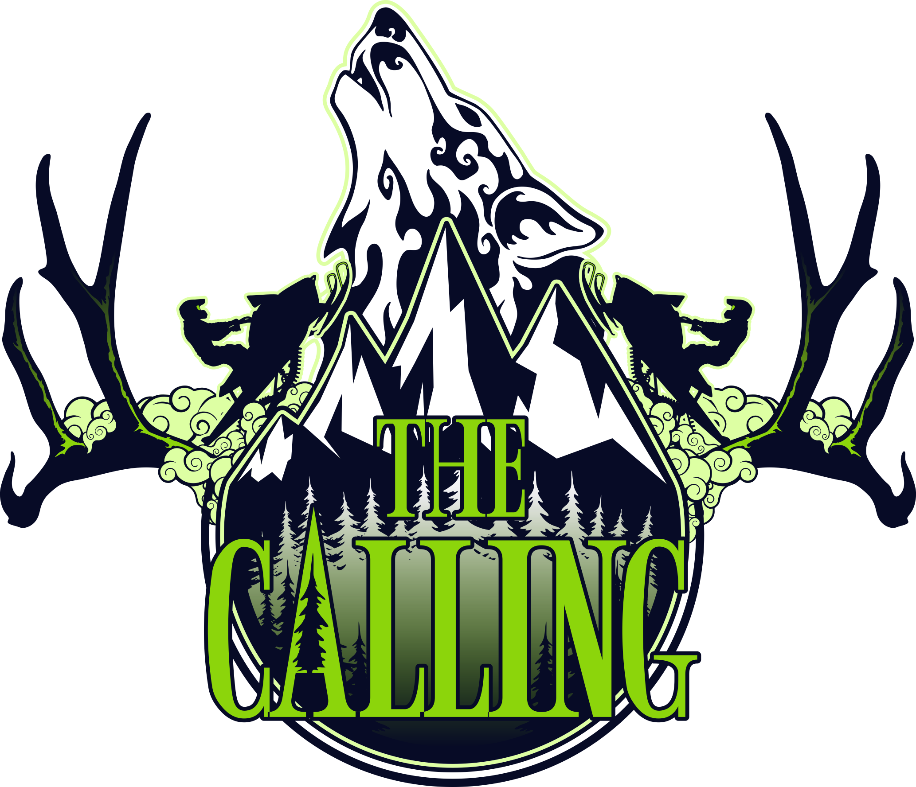

BASE CAMP COORDINATOR

THE CALLING 2018

A MOUNTAIN SNOWMOBILE FESTIVAL and NON-PROFIT FUNDRAISER

|  |  |  |
| --- | --- | --- |
| SKADI Foundation Box 362 Revelstoke BC V0E 2S0 |  | skadifoundation@gmail.com  http://www.skadifoundation.com |

Table of Contents

1. The Calling Profile 2

Mission Statement

Objectives

Organizational Chart

1. Activity Profile 4
2. Coordinator Roles and Responsibilities 5
3. Contacts Sheet 6
4. Timeline and Activity Schedules 7
5. Budget 15
6. Marketing 16
7. Legal and Liability Management 17
8. Policies 18

Code of Conduct

Policies in Review

1. Risk Management 19
2. Site Plan 21
3. Equipment 23
4. Contractors 23
5. Volunteers 24
6. Sponsors 25
7. Stakeholders and Community Resources 25
8. Additional Notes 25

# The Calling Profile

## Mission Statement

*The Calling* is an annual snowmobiling festival in Revelstoke, British Columbia that generates funding for non-profit groups, shifts the culture of safe backcountry mountain motorized use practices, generates community revenue and exposure for Revelstoke as a world-class snowmobiling destination.

## Objectives

The objectives of *The Calling* are as follows:

* Establish an annual snowmobiling festival in Revelstoke, BC specific to the winter sport community that includes a prestigious Cross Country Snowmobiling Race, Vendor Village, Freestyle Demonstrations, Education Clinics and Entertainment.
* Devise a strict Risk Management Plan that includes an effective Emergency Response Plan; these plans should set a new precedence in the industry and be used as a legacy for succeeding winter sport events.
* Raise funds for local non-profits.
* Provide educational opportunities that direct a shift in the culture of safe backcountry mountain motorized use practices.
* Work with local volunteers and clubs to achieve an inclusive community event.
* Use community resources wherever possible to generate community revenue.
* Cross-market Revelstoke, British Columbia and Canada as a world-class snowmobiling destination.
* Maximize marketing opportunities for sponsors and stakeholders.

## Organizational Chart

Attached Organization Chart.



# Activity Profile

Base Camp is *The Calling’s* nerve center. Base Camp is fully operational during the three days of the festival and partially operational for set-up prior to the festival and take-down after the festival. The proposed location for Base Camp is the Revelstoke Ball Diamonds. Base Camp hosts all four festival user groups.

*Vital Services*

* Medical Aid
* Incident Command Center
* Operations Tent: Host operational meetings including Morning Safety/Operations Meetings and Safety Debrief Meeting in the evening. Host free breakfasts.
* Public Health: Porta Potty and waste management areas
* Volunteers Headquarters
* Guest Services Hub: provide support to all four user groups.
  + Spectator/General Public/VIP/Participant: Concierge (maps, questions, transportation arrangements, phone book, assistance), Clinic Pass purchases, Clinic Registration
  + *The Calling* Member/Contractor/Volunteer: Concierge (maps, questions, assistance), access to an organizational chart for reference and protocol guidebook for specific inquiries
  + Stakeholder/Vital Service/Media: Concierge (maps, questions, assistance), access to an organizational chart for reference and protocol guidebook for specific inquiries
  + Dealer/Supplier/Manufacturer/Professional Athlete/Entertainer/Food or Drink Vendor: Concierge (maps including vendor map, questions, assistance)
  + Sell *The Calling* merchandise
  + Maps: Vendor Map, Festival Map, Revelstoke Map

*Vendor Village, Special Events and Freestyle Demonstrations*

* Dealers/Suppliers/Manufacturers booths: selling snowmobiles, snow bikes, gear and accessories, Rider Autograph booths, *The Calling* Merchandise Booth, Selfie Booth
* Sponsor/Stakeholder/Community Resources booths
* Entertainment: Event Live Feeds, DJ/Radio Station and Live Bands, Bonfire Pit, Chili Cook-off, Presentations and Ceremonies
* Food/Drink Vendors: Beer Gardens, 5 local food vendors
* Freestyle Demonstrations
* Kids Zone: face painting, mini sled races, bouncy castle

# Coordinator Roles and Responsibilities

The Coordinator works directly with the Festival Coordinator. The following is a summary of the Coordinator’s responsibilities:

* Design a proposal that meets the requirements outlined in the Activity Profile and follows *The Calling’s* objectives and Coordinator Package Template.
* The Coordinator of the winning proposal must make any changes required by the Boards in accordance with their contract and resubmit their package for final approval. The Festival Coordinator is then responsible for forwarding the approved package to the Executive Administration Assistant and relevant Coordinators indicated in each section of the package.
* Ensure the Festival Coordinator, Executive Administrative Assistant and relevant Coordinators indicated in each section of the package are immediately notified regarding changes to the package leading up to the festival and during the festival.
* Submit detailed schedules for all persons involved with their Activity.
* The Coordinator is required to attend the daily Morning Safety/Operations Meetings and Safety/Operations Debrief Meetings during the festival.
* Provide a general budget for their Activity.
* Work within the Legal and Liability Management outline provided by *The Calling* and provide insight on potential Legal and Liability Management issues within their area of responsibility.
* Submit the Risk Assessment Package for their Activity and work within the Risk Management outline provided by the Base Camp Safety Coordinator.
* Appoint a designated emergency response lead at the site of their Activity who in the event of an Emergency follows the steps outlined in the Emergency Procedures Insert at the front of the final Coordinator Package.
* The Coordinator must contract, supply and is responsible for equipment required to conduct their Activity.
* The Coordinator must hire and is responsible for sub-contractors required to conduct their Activity.
* Collect and provide feedback for Festival Debrief Meeting.
* The Coordinator must ensure their Activity is conducted in compliance with *The Calling’s* Code of Conduct and Policies*.*

# Contacts Sheet

The Coordinator must submit a Contacts Sheet for persons involved in their Activity. The Festival Coordinator, Executive Administration Assistant and the Base Camp Safety Coordinator must be notified immediately if changes are made to the Contacts Sheet.

|  |  |  |  |
| --- | --- | --- | --- |
| **BASE CAMP COORDINATOR**  **CONTACTS SHEET** | | | |
| **Name** | **Role** | **Email** | **Phone** |
| (enter later) | Executive Administrative Assistant | (enter later) | (enter later) |
|  | Festival Coordinator |  |  |
|  | Cross Country Race Director |  |  |
|  | Freeride Competition Director |  |  |
|  | Avalanche Awareness and Riding Clinics Director |  |  |
|  | Photo and Video Challenges Director |  |  |
|  | Social Events Coordinator |  |  |
|  | Marketing Coordinator |  |  |
|  | Communications Director |  |  |
|  | Merchandise Director |  |  |
|  | Website Director |  |  |
|  | Social Media Director |  |  |
|  | Media Production Coordinator |  |  |
|  | Base Camp Media Production Director |  |  |
|  | Backcountry Media Production Director |  |  |
|  | Freeride Competition Media Production Coordinator |  |  |
|  | Base Camp Coordinator |  |  |
|  | Base Camp Safety Coordinator |  |  |
|  | Backcountry Safety Coordinator |  |  |
|  | Volunteers Coordinator |  |  |
|  |  |  |  |
|  | (Additional contacts may be entered later) |  |  |
|  | Contractor |  |  |
|  |  |  |  |
|  |  |  |  |
|  |  |  |  |
|  |  |  |  |
|  |  |  |  |

# Timeline and Activity Schedules

The Coordinator must submit schedules for all persons involved in their Activity. The Festival Coordinator, Base Camp Safety Coordinator, Executive Administrative Assistant and Marketing Coordinator (relevant information) must be notified immediately if changes are made to the timeline and schedules.

|  |  |  |
| --- | --- | --- |
| **THE CALLING 2018 PROJECT**  **DEVELOPMENT/IMPLEMENTATION TIMELINE**  **2017-2018** | | |
| 2017  Project Development  Budgets  Fundraising  Communications  Scheduling  Implementation  Monitoring  Problem Management | | * May-Sep: PHASE 1 – BUDGET DEVELOPMENT * Complete Draft 3 of Operations and Business Plans * Coordinators/Directors submit proposals; upon acceptance revisions required by Board * Fill all positions * Definitive Budgets (+10% to -10% accuracy) * Finalize Coordinator/Director Packages * Jul-Sep: PHASE 2 – FUNDRAISING STRATEGY * Team Meeting * Fundraising Strategies Brainstorm Session * Team Resources and Skills Assessment * Establish Sponsorship Structure/The Calling 2018 Branding * Media Development for fundraising strategies * Strategy Launches * Jul-Sep: PHASE 3 – COMMUNICATIONS * Team Communication Strategies/Templates * Stakeholder Communication Strategies/Templates * Media Communication Strategies/Templates * Jul-Sep: PHASE 4 – SCHEDULING * Work Breakdown Structures, GANTT Charts, Milestones Chart (visually easy to follow) * Deadlines, follow-up, accountability, monitoring * Status Updates and Status Reports * Sep-Dec: PHASE 5 – IMPLEMENTATION * Deposits to Coordinators/Directors * Booking * Permits/Government Approvals * Public Consultations * Vital Services Meetings * Policy Development * Launch Marketing Strategy * Sep-Dec: PHASE 6 – MONITORING * Follow-up * Team and Stakeholder Communications * Sep-Dec: PHASE 7 – PROBLEM MANAGEMENT * Assist team with staying on track |
| 2018  Implementation  Monitoring  Problem Management  Closing | | * Jan-Mar: PHASES 5-7 * Jan: Confirm contractors and rentals * Feb: Plan review and last-minute corrections * Mar: Festival set-up and take-down * Mar-Apr: PHASE 8 – CLOSING * Apr: Appreciation to Volunteers, Stakeholders, The Calling Members and Contractors * Apr: Festival Debrief and develop The Calling 2019 Plan * May: Present The Calling 2019 Plan to Stakeholders |
| **BASE CAMP COORDINATOR**  **DEVELOPMENT/IMPLEMENTATION TIMELINE**  **2017-2018** | | |
| Activities that need to be included in Timeline | * Work with Exec Admin Team on Policy Development * Meet with Base Camp Safety Coordinator to develop Risk Management Plan * Submit Volunteers Request to Volunteers Coordinator * Submit safety gear, radios, barriers and pylons request to Base Camp Safety Coordinator * Meet with Marketing Coordinator to develop/pick-up/distribute marketing content * digital and printed advertising poster, newspaper ad, radio ad, badges and identifiers, Base Camp Admissions wristbands, signage (event indicator, crowd control, traffic control), sponsor banners, swag bag, custom webpage (feature entertainment schedule, vendor list, Base Camp Map, schedule changes, location changes), working group webpage (schedules for user groups), social media ads (advertise feature entertainment 1 hour prior to schedule time, photo-op strategy {and develop custom filter?}). * Point-of-Sale, cash floats for Base Camp Admissions and Guest Hub (merchandise, clinic pass sales) * Internet capabilities for Volunteers Headquarters, Guest Services Hub, Incident Command Center * Obtain Swag Bag fillers (coupons, vendor specials, community info, etc.) * Participant – Competitive (CCR, Freeride, Photo/Video Challenges) * Participant – Non-Competitive (Ava/Rid Clinics and Social Events) * Base Camp Guests * Fill and distribute Swag Bags to Coordinators/Directors * Book heli-tour vendor, may need to coordinate with Backcountry Safety Coordinator * Book shuttle services for VIPS, headliner band, major sponsors * Chili Cook-off Terms and Conditions, Registration Forms * Copy of Site Plan to: Photo and Video Challenges Director, Social Events Coordinator, Marketing Coordinator, Media Production Base Camp Director, Base Camp Safety Coordinator * Write ceremony scripts and discuss with Admin Team (professional invitations to be produced by Admin Team or Marketing Coordinator) * Hire Host for daily announcements, ceremonies etc. * Meet with Freeride Competition Media Production and Backcountry Media Production Director to establish live feed requirements at Base Camp * Meet with Social Events Coordinator to discuss Pub Crawl, Headliner Band and family friendly event requirements * Meet with Cross Country Race and Freeride Competition Directors to discuss Racer Pit requirements and Participant schedules/outline (Ceremonies and Meet and Greet) * Meet with Photo and Video Challenges Director to discuss presentation requirements, schedules and live voting kiosk locations * Meet with Base Camp Media Production Director to discuss layouts, boundaries and schedules * Meet with Backcountry and Base Camp Safety Coordinators to discuss Incident Command Center requirements, communication options for in-field people to participate in safety meetings, plans for heli-pad usage schedule * Meet with Social Media Director to establish Base Camp Photo Op Strategy (uploading to social media, hashtags, digital frames or printed frame at Base Camp, use Luster or similar product?) * Meet with Merchandise Director to discuss Guest Services Hub merchandise layout and POS requirements * Meet with Volunteers Coordinator to discuss Volunteers Headquarters requirements | |
| 2017 | * Sep * Submit Proposal, complete required adjustments * Attend Fundraiser Meeting * Secure Base Camp location * Oct * Send packages/information to vendors and sponsors * Obtain quotes from contractors for stage set-up, fencing, tables, etc. * Nov * Book/confirm vendors, entertainment, free breakfast caterer, beer gardens * Dec | |
| 2018 | * Jan * Confirm contractors and rentals * Confirm permits * Collect giveaways * Collect items or swag bags from vendors * Feb * Plan review and last-minute corrections * Collect vendor fees, provide vendor package (schedules, locations, guidelines) * Mar * Conduct Volunteer Briefing Meeting with volunteers scheduled to work within your area of responsibility * Collect/distribute badges and identifiers from Marketing Coordinator * Collect and distribute safety gear and radios from Base Camp Safety Coordinator * Apr * Collect Feedback * Collect/return safety gear and radios to Base Camp Safety Coordinator * Attend Festival Debriefing Meeting | |
| As at XXX, 2017 | | |

|  |  |
| --- | --- |
| **DAILY BASE CAMP SCHEDULE**  **March 29 – April 2, 2018** | |
| Thursday,  March 29  Set-up | * 7:00am - 8:00am: Festival Set-up Meeting * 8:00am - 9:00am: Festival Stakeholders and Vital Services Meeting * 10:00am - 6:00pm: Tents, Vendors, Stage, Beer Gardens, Porta Pottys, Waste Management * 1:00pm - 2:00pm: *The Calling* Members Meeting * 2:00pm - 3:00pm: Safety Teams (2) Meeting * 3:00pm - 4:00pm: Volunteers Meeting * 5:00pm - 6:00pm: Media Production Teams (3) Meeting * 6:00pm - 7:00pm: Participant Meeting * Media Test Runs with Photo and Video Challenges Director and Media Production Teams |
| Friday, March 30  STAT  Festival Day 1 | * 7:00am - 8:00am: Festival Safety Meeting * 8:00am - 10:00am: Festival Operations Meeting (8-9) and Free Breakfast * 10:00am - 6:00pm: Vendor Village/Kids Zone/DJ Music/Live Bands * 10:00am - 7:00pm: Beer Gardens * X:00am - X:00am: Top 10s Photo and Video Challenge Presentation * 5:00pm - 6:00pm: Opening Ceremony * 6:00pm - 7:00pm: Happy Hour, Festival Recap * 6:00pm - 7:00pm: Rider Introductions and Meet and Greet * 7:00pm - 8:00pm: Safety/Operations Debrief Meeting * 8:00pm - 12:00am: Non-Profit Fundraiser – Pub Crawl |
| Saturday, March 31  Festival Day 2 | * 7:00am - 8:00am: Festival Safety Meeting * 8:00am - 10:00am: Festival Operations Meeting (8-9) and Free Breakfast * 10:00am - 6:00pm: Vendor Village/Kids Zone/DJ Music/Live Bands * 10:00am - 12:00am: Beer Gardens * X:00am - X:00am Chili Cook-off starts TBA judging times * 11:00am - 11:30am: Freestyle Demonstration * 2:00pm - 2:30pm: Freestyle Demonstration * 6:00pm - 7:00pm: Happy Hour, Festival Recap * 7:00pm - 8:00pm: Safety/Operations Debrief Meeting * 7:00pm - 8:00pm: Stage set-up for Headliner Band * 8:00pm - 12:00am: Headliner Band |
| Sunday, April 1  Festival Day 3 | * 7:00am - 8:00am: Festival Safety Meeting * 8:00am - 10:00am: Festival Operations Meeting (8-9) and Free Breakfast * 10:00am - 6:00pm: Vendor Village/Kids Zone/DJ Music/Live Bands * 10:00am - 7:00pm: Beer Gardens * 12:00pm - 12:30pm: Freestyle Demonstration * 5:00pm - 6:00pm: Closing Ceremony and Awards * 6:00pm - 7:00pm: Happy Hour, Festival Recap * 7:00pm - 8:00pm: Safety/Operations Debrief Meeting |
| TBA | * Non-Profit Fundraiser – Family Friendly |
| Monday, April 2  Take-down | * 8:00am - 9:00am: *The Calling* Members and Stakeholders Meeting * 9:00am - 10:00am: Participant Meeting * 9:00am - 6:00pm: Vendors, Tents, Stage, Beer Gardens, Porta Pottys, Waste Management |
| As at XXX, 2017 | |

|  |  |
| --- | --- |
| **DAILY BASE CAMP SCHEDULE**  **COORDINATOR**  **March 29 – April 2, 2018** | |
| Thursday,  March 29 | * 7:00am - 8:00am: Festival Set-up Meeting * 8:00am - 6:00pm: Oversee set-up at Base Camp |
| Friday, March 30  STAT | * 7:00am - 8:00am: Festival Safety Meeting * 8:00am - 10:00am: Festival Operations Meeting (8-9) and Free Breakfast * 10:00am - 7:00pm: Oversee Base Camp operations * 7:00pm - 8:00pm: Safety/Operations Debrief Meeting |
| Saturday, March 31 | * 7:00am - 8:00am: Festival Safety Meeting * 8:00am - 10:00am: Festival Operations Meeting (8-9) and Free Breakfast * 10:00am - 7:00pm: Oversee Base Camp Operations * 7:00pm - 8:00pm: Safety/Operations Debrief Meeting |
| Sunday, April 1 | * 7:00am - 8:00am: Festival Safety Meeting * 8:00am - 10:00am: Festival Operations Meeting (8-9) and Free Breakfast * 10:00am - 7:00pm: Oversee Base Camp operations * 7:00pm - 8:00pm: Safety/Operations Debrief Meeting |
| Monday, April 2 | * 8:00am - 9:00am: *The Calling* Members and Stakeholders Meeting * 9:00am - 6:00pm: Oversee take-down and site clean-up at Base Camp |
| As at XXX, 2017 | |

|  |  |
| --- | --- |
| **DAILY BASE CAMP SCHEDULE**  **VOLUNTEER**  **March 30 – April 1, 2018** | |
| Friday, March 30  STAT | * 7:00am - 8:00am: Festival Safety Meeting * 8:00am - 10:00am: Festival Operations Meeting (8-9) and Free Breakfast * 7:00pm - 8:00pm: Safety/Operations Debrief Meeting |
| Saturday, March 31 | * 7:00am - 8:00am: Festival Safety Meeting * 8:00am - 10:00am: Festival Operations Meeting (8-9) and Free Breakfast * 7:00pm - 8:00pm: Safety/Operations Debrief Meeting |
| Sunday, April 1 | * 7:00am - 8:00am: Festival Safety Meeting * 8:00am - 10:00am: Festival Operations Meeting (8-9) and Free Breakfast * 7:00pm - 8:00pm: Safety/Operations Debrief Meeting |
| As at XXX, 2017 | |

|  |  |
| --- | --- |
| **DAILY BASE CAMP SCHEDULE**  **The Calling Members – Coordinators and Directors**  **March 29 – April 2, 2018** | |
| Thursday,  March 29 | * 7:00am - 8:00am: Festival Set-up Meeting * 1:00pm - 2:00pm: *The Calling* Members Meeting * 2:00pm - 3:00pm: Safety Teams (2) Meeting * 3:00pm - 4:00pm: Volunteers Meeting * 5:00pm - 6:00pm: Media Production Teams (3) Meeting * Media Test Runs with Photo and Video Challenges Director and Media Production Teams |
| Friday, March 30  STAT | * 7:00am - 8:00am: Festival Safety Meeting * 8:00am - 10:00am: Festival Operations Meeting (8-9) and Free Breakfast * 5:00pm - 6:00pm: Opening Ceremony * 7:00pm - 8:00pm: Safety/Operations Debrief Meeting |
| Saturday, March 31 | * 7:00am - 8:00am: Festival Safety Meeting * 8:00am - 10:00am: Festival Operations Meeting (8-9) and Free Breakfast * 7:00pm - 8:00pm: Safety/Operations Debrief Meeting |
| Sunday, April 1 | * 7:00am - 8:00am: Festival Safety Meeting * 8:00am - 10:00am: Festival Operations Meeting (8-9) and Free Breakfast * 5:00pm - 6:00pm: Closing Ceremony and Awards * 7:00pm - 8:00pm: Safety/Operations Debrief Meeting |
| Monday, April 2 | * 8:00am - 9:00am: *The Calling* Members and Stakeholders Meeting |
| As at XXX, 2017 | |

|  |  |
| --- | --- |
| **DAILY BASE CAMP SCHEDULE**  **Contractors and Sub-Contractors**  **March 29 – April 2, 2018**  *Contractors hired by Base Camp to set-up and take-down* | |
| Thursday,  March 29  Set-up | * 7:00am - 8:00am: Festival Set-up Meeting * 10:00am - 6:00pm: Tents, Vendors, Stage, Beer Gardens, Porta Pottys, Waste Management |
| Friday, March 30  STAT |  |
| Saturday, March 31 |  |
| Sunday, April 1 |  |
| Monday, April 2  Take-down | * 9:00am - 6:00pm: Vendors, Tents, Stage, Beer Gardens, Porta Pottys, Waste Management |
| As at XXX, 2017 | |

|  |  |
| --- | --- |
| **DAILY BASE CAMP SCHEDULE**  **Participant – Competitive**  **(Cross Country Race, Freeride Competition, Photo and Video Challenges, Chili Cook-off)**  **March 29 – April 2, 2018** | |
| Thursday,  March 29 | * 10:00am - 6:00pm: Vendor set-up (CCR, Freeride) * 6:00pm - 7:00pm: Participant Meeting (CCR and Freeride) |
| Friday, March 30  STAT | * 7:00am - 8:00am: Festival Safety Meeting (CCR, Freeride) * 8:00am - 10:00am: Free Breakfast (CCR, Freeride) * X:00am - X:00am: Top 10s Photo and Video Challenge Presentation * 5:00pm - 6:00pm: Opening Ceremony (CCR, Freeride) * 6:00pm - 7:00pm: Festival Recap * 6:00pm - 7:00pm: Rider Introductions and Meet and Greet (CCR, Freeride) * 7:00pm - 8:00pm: Safety/Operations Debrief Meeting (CCR, Freeride) |
| Saturday, March 31 | * 7:00am - 8:00am: Festival Safety Meeting (CCR, Freeride) * 8:00am - 10:00am: Free Breakfast (CCR, Freeride) * X:00am - X:00am Chili Cook-off starts TBA judging times * 6:00pm - 7:00pm: Festival Recap * 7:00pm - 8:00pm: Safety/Operations Debrief Meeting (CCR, Freeride) |
| Sunday, April 1 | * 7:00am - 8:00am: Festival Safety Meeting (CCR, Freeride) * 8:00am - 10:00am: Free Breakfast (CCR, Freeride) * 5:00pm - 6:00pm: Closing Ceremony and Awards (CCR, Freeride, Phot/Vid) * 6:00pm - 7:00pm: Festival Recap * 7:00pm - 8:00pm: Safety/Operations Debrief Meeting |
| TBA | * Non-Profit Fundraiser – Family Friendly |
| Monday, April 2 | * 9:00am - 10:00am: Participant Meeting (CCR, Freeride) * 9:00am - 6:00pm: Vendor Take-down (CCR, Freeride) |
| As at XXX, 2017 | |

|  |  |
| --- | --- |
| **DAILY BASE CAMP SCHEDULE**  **Vendors**  **March 29 – April 2, 2018** | |
| Thursday,  March 29  Set-up | * 10:00am - 6:00pm: Tents, Vendors, Stage, Beer Gardens, Porta Pottys, Waste Management |
| Friday, March 30  STAT | * 10:00am - 6:00pm: Vendor Village/Kids Zone/DJ Music/Live Bands |
| Saturday, March 31 | * 10:00am - 6:00pm: Vendor Village/Kids Zone/DJ Music/Live Bands |
| Sunday, April 1 | * 10:00am - 6:00pm: Vendor Village/Kids Zone/DJ Music/Live Bands |
| TBA | * Non-Profit Fundraiser – Family Friendly (May effect Vendors) |
| Monday, April 2  Take-down | * 9:00am - 6:00pm: Vendors, Tents, Stage, Beer Gardens, Porta Pottys, Waste Management |
| As at XXX, 2017 | |

|  |  |
| --- | --- |
| **DAILY BASE CAMP SCHEDULE**  **Entertainment**  **March 29 – April 2, 2018** | |
| Thursday,  March 29  Set-up | * 10:00am - 6:00pm: Tents, Vendors, Stage, Beer Gardens, Porta Pottys, Waste Management |
| Friday, March 30  STAT  Festival Day 1 | * 10:00am - 6:00pm: Vendor Village/Kids Zone/DJ Music/Live Bands |
| Saturday, March 31  Festival Day 2 | * 10:00am - 6:00pm: Vendor Village/Kids Zone/DJ Music/Live Bands * 11:00am - 11:30am: Freestyle Demonstration * 2:00pm - 2:30pm: Freestyle Demonstration * 7:00pm - 8:00pm: Stage set-up for Headliner Band * 8:00pm - 12:00am: Headliner Band |
| Sunday, April 1  Festival Day 3 | * 10:00am - 6:00pm: Vendor Village/Kids Zone/DJ Music/Live Bands * 12:00pm - 12:30pm: Freestyle Demonstration |
| Monday, April 2  Take-down | * 9:00am - 6:00pm: Vendors, Tents, Stage, Beer Gardens, Porta Pottys, Waste Management |
| As at XXX, 2017 | |

|  |  |
| --- | --- |
| **DAILY BASE CAMP SCHEDULE**  **Vested Parties (VIPs, Stakeholders, Vital Services Reps, Sponsors, Media, Political Reps)**  **March 29 – April 2, 2018** | |
| Thursday,  March 29  Set-up | * 8:00am - 9:00am: Festival Stakeholders and Vital Services Meeting |
| Friday, March 30  STAT  Festival Day 1 | * 5:00pm - 6:00pm: Opening Ceremony |
| Saturday, March 31  Festival Day 2 |  |
| Sunday, April 1  Festival Day 3 | * 5:00pm - 6:00pm: Closing Ceremony and Awards |
| Monday, April 2  Take-down | * 8:00am - 9:00am: *The Calling* Members and Stakeholders Meeting |
| As at XXX, 2017 | |

# Budget

The budget of $XX,XXX has been allocated to this area of responsibility. The Coordinator must provide a general breakdown of projected expenses for the Activity. Include in-kinds and potential receivables.

The budget in this area of responsibility may include: Coordinator salary, tent rentals, Porta Potty rentals, waste management rentals, headsets, catering (free breakfasts), freestyle demonstration fees.

Items supplied by other areas of responsibility include: marketing materials indicated in Marketing section supplied by Marketing Coordinator; safety gear, radios, barriers and pylons supplied by Base Camp Safety Coordinator; Safety Teams supplied by Base Camp Safety Coordinator.

Potential Receivables in this area of responsibility may include: Base Camp Admission Fees, Chili Cook-off Registration Fees, Vendor Booth Fees

# Marketing

Marketing for this area of responsibility is supplied by the Marketing Coordinator. Items in the Marketing Plan specific to this area of responsibility include: digital and printed advertising poster, newspaper ad, radio ad, badges and identifiers, Base Camp Admissions wristbands, signage (event indicator, crowd control, traffic control), sponsor banners, swag bag, custom webpage (feature entertainment schedule, vendor list, Base Camp Map, schedule changes, location changes), working group webpage (schedules for user groups), social media ads (advertise feature entertainment 1 hour prior to schedule time, photo-op strategy {and develop custom filter?}).

The Coordinator must submit a request for marketing materials, provide content, and notify the Marketing Coordinator of any incorrect or updated information for the website and social media regarding their area of responsibility.

It is an objective of *The Calling* to maximize marketing opportunities for sponsors and stakeholders. The Coordinator must provide insight to and submit requests to the Marketing Coordinator for marketing opportunities within their area of responsibility for example: promotions, cross-marketing and merchandise.

# Legal and Liability Management

The Coordinator must work within the Legal and Liability Management outline provided by *The Calling.* The Coordinator must provide insight on potential Legal and Liability Management issues within their area of responsibility.

Potential Legal and Liability Management within this area of responsibility include:

* Role Contract
* Collect required copies for due diligence: waivers (participant, sub-contractors, volunteers, vendors), contracts, certificates, permits, licenses, sub-contractor WCB clearance letters
* Event Permit
* Radio Use Permit
* Liability Insurance
* Policy Development: Handicap Accessibility, removal of guest/participant causing a disturbance, Fee Refund
* Liquor License/Serve it Right Certificate
* Building Permit (stage, liquor storage, Beer Gardens)
* Food Services Permit/Foodsafe / Health Certificate (Operations Tent)
* Fire Permit
* Electrical Permit
* BC Safety Authority Permit
* Sign Permit
* Noise Bylaw (generators, mini sled races, Freestyle Demonstration)
* Field Rental Agreement

# Policies

## Code of Conduct

Members of *The Calling*, Contractors and Volunteers actively representing *The Calling* must behave in a professional, safe manner and act in the best interest of *The Calling*. Alcohol consumption and drug use is detrimental to *The Calling’s* vision of providing a safe, community event and is not acceptable.

## Policies in Review

The following policies are in review for this area of responsibility: Handicap Accessibility, removal of guest/participant causing a disturbance, Fee Refund

# Risk Management

It is an objective of *The Calling* to devise a thorough Risk Management Plan that includes an effective Emergency Response Plan. Risk Assessment Packages assist Safety Coordinators in the development of Risk Management Plans and ensure Vital Service requirements are in place at each Activity. The following plans are explored in the Risk Assessment Package: Master Site Plan, Medical Plan, Security Plan, Public Health Plan, Fire Safety Plan, Communications Plan, Traffic Management Plan, Liquor Control Plan, Other Contingency Plans.

The Base Camp Safety Coordinator will assist with developing and finalizing the Risk Assessment Package for this area of responsibility. The Coordinator must work within the finalized Risk Management Plan provided by the Base Camp Safety Coordinator. The Coordinator must appoint a designated emergency response lead at the site of the Activity who in the event of an emergency follows the steps outlined in the Emergency Procedures Insert (provided by the Base Camp Safety Coordinator) at the front of the final Coordinator Package. The Festival Coordinator, Base Camp Safety Coordinator and the Executive Administration Assistant must be notified immediately if changes are made to the Risk Management Plan.

The following planning considerations will be reviewed in the Risk Assessment Package for this area of responsibility:

### Medical Plan

medical personnel, equipment and sources, medical personnel schedules, transportation plan (emergency and non-emergency), medical team communications, incident documentation plan, insurance for medical team, medical tent

### Security Plan

communications and equipment protocol, security schedule and locations, security protocol, emergency security protocol, spectators calling 911 without notifying event organizers/staff protocol, incident documentation plan

### Public Health Plan

Porta Pottys, waste management, site clean-up

### Fire Safety Plan

fire safety crew, communications and equipment protocol, fire control personnel schedule and locations, fire safety equipment locations, fire response protocol, burn permit

### Communications Plan

designated communications lead, communication devices, media access arrangements, pre-scripted messages for delay/cancellation/evacuation, spectator/volunteer/contractor/participant messaging, event safety messages

### Traffic Management Plan

traffic engineer, traffic control contractor, traffic control personnel schedule and locations, emergency response route protocol, route signage, police assistance, parkin arrangements, communications plan

### Liquor Control Plan

secure liquor storage and distribution, liquor policy, special occasion licence

### Other Contingency Plans

lost person protocol, disability access, weather, evacuation plan, delay/cancellation protocol, emergency response protocol

Additional Risk Management within this area of responsibility include:

# Site Plan

The location for the Base Camp is pre-determined by *The* Calling. The proposed location for Base Camp is Revelstoke Ball Diamonds. The Coordinator must provide a detailed Site Plan which includes the following: Access/Exit Routes, Disability Access/Exit, Accessible Facilities, Parking Plan, Vender/Supplier Areas, Stage/Spectator Area, Perimeter, Staff/VIP/Media Areas, Medical Layout, Media Areas, Liquor Service Areas, Security Layout, Porta Potty areas, Waste Management Area, Designated Smoking Area.

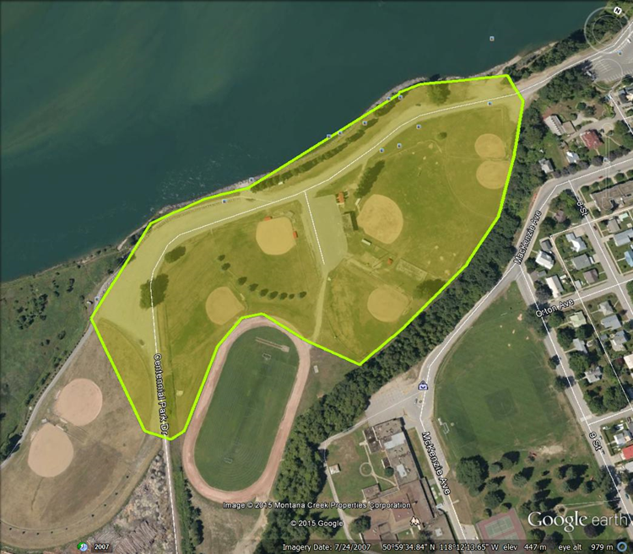

Base Camp (Revelstoke Ball Diamonds)

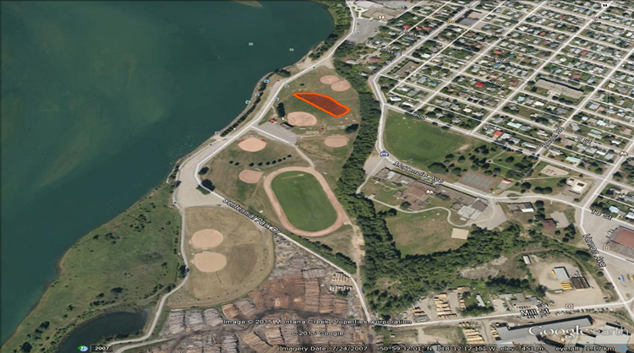

Freestyle Demonstration (Revelstoke Ball Diamonds)

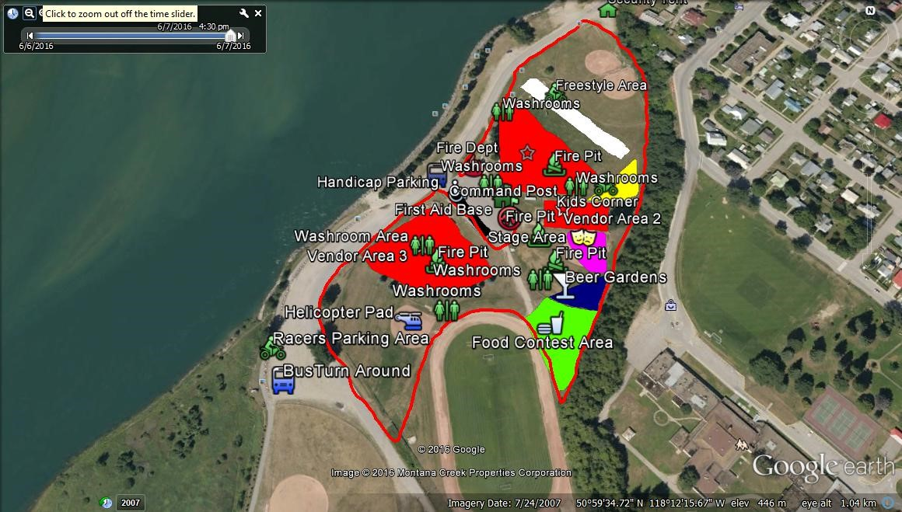

SAMPLE LAYOUT

{INSERT MAP HERE}

# Equipment

It is an objective of *The Calling* to use community resources wherever possible to generate community revenue. The Coordinator must contract, supply and are responsible for equipment needed to conduct their Activity. The cost for equipment is outlined in the budget.

Equipment required in this area of responsibility may include:

# Contractors

It is an objective of *The Calling* to use community resources wherever possible to generate community revenue. The Coordinator is responsible for hiring Contractors. Contractors hired must be in good standing with WCB. The Coordinator must collect insurance, waivers and other pertinent documents from their Contractors and submit copies to the Festival Coordinator for proof of due diligence. A list of potential/confirmed Contractors should be provided here.

Contractors required in this area of responsibility may include:

# Volunteers

It is an objective of *The Calling* to achieve an inclusive community event; Coordinators are encouraged to access volunteers and community groups wherever possible. Coordinators must submit a Request for Volunteers to the Volunteers Coordinator and include the information sampled in table below. For liability and security purposes all volunteers must be registered by the Volunteers Coordinator.

The Volunteers Coordinator recruits and schedules volunteers, ensures relevant waivers and Criminal Record Checks are completed, and collects copies of required certifications and licenses. Volunteers must not be given money or gift certificates for their services. The Coordinator may contact the Volunteers Coordinator if a scheduled volunteer does not show up for their shift.

A list of potential/confirmed Volunteer opportunities should be provided here.

|  |  |  |  |
| --- | --- | --- | --- |
| **REQUEST FOR VOLUNTEERS** | | | |
|  | **General Job Description** | **Requirements** | **Safety Gear/**  **Certificates/Licenses** |
| **Base Camp** |  |  |  |
| Guest Services (1) | Help all festival user groups with directions and any other questions they may have | {What days/hours?} | Vests |
|  |  |  |  |

Volunteer opportunities for this area of responsibility may include: public consultations meeting notetaker, guest services,

Volunteers to be requested by the Base Camp Safety Coordinator may include: members of the Base Camp Safety Teams (Security, Traffic, Medical, Fire).

# Sponsors

It is an objective of *The Calling* to maximize marketing opportunities for sponsors and stakeholders. The Coordinator must provide a list of sponsor marketing opportunities within their Activity.

Sponsor Opportunities for this area of responsibility may include:

# Stakeholders and Community Resources

The Coordinator must provide a list of stakeholders and organizations that may be effected by or could provide insight to their Activity and may need to be solicited.

Stakeholders that may be effected by this area of responsibility may include:

# Additional Notes

**© 2017 SKADI Foundation ALL RIGHTS RESERVED**

Plans contained in this document are owned and protected by SKADI Foundation. No part may be reproduced in the development of a similar event without prior written permission from SKADI Foundation. No part of this work may be reproduced or used in any form or by any means – graphic, electronic, or mechanical, including photocopying, recording, taping, or information storage and retrieval systems – without prior written permission from SKADI Foundation.

SKADI Foundation

Box 362

Revelstoke BC V0E 2S0

skadifoudation@gmail.com

http://www.skadifoundation.com

Writer: Jeremy Hanke

Writer/Editor: Misty Bergquist

Contributors: Craig Moore, Duncan Lee, Emily Roberts, Erik Luzak, Jaclyn Moore, Jeff Scott, Mark Karlstrom,

Robert Sim, Scott Wickson