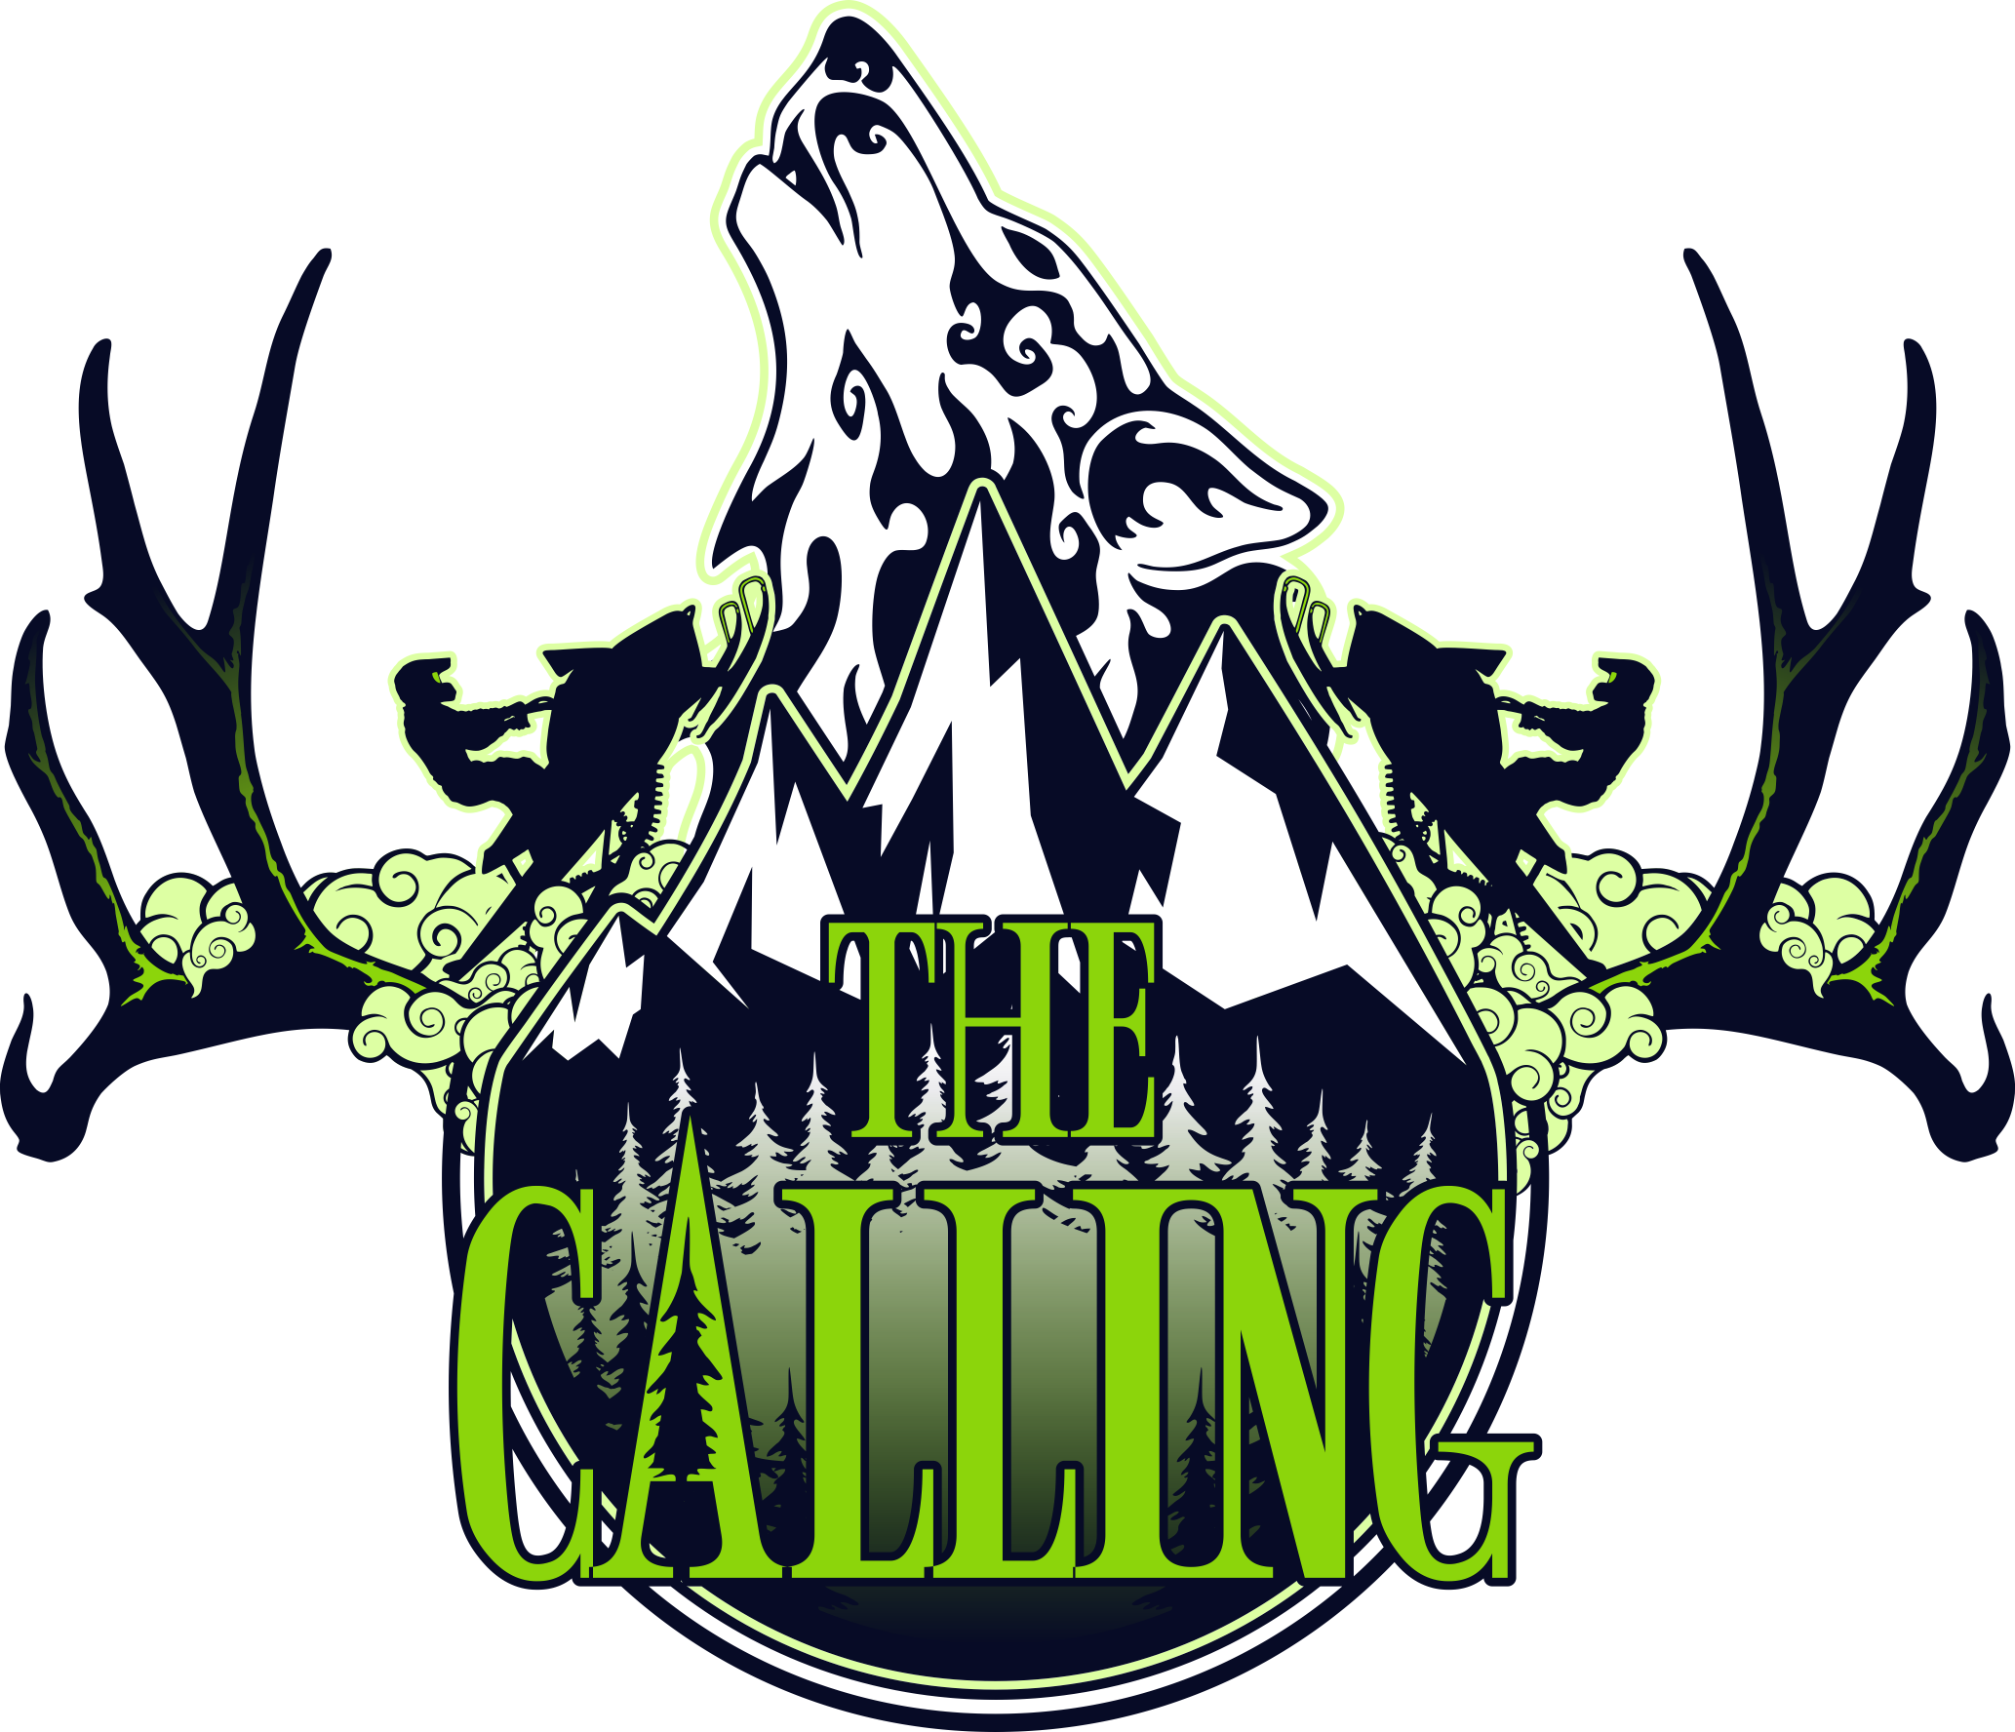

SOCIAL EVENTS COORDINATOR

THE CALLING 2018

A MOUNTAIN SNOWMOBILE FESTIVAL and NON-PROFIT FUNDRAISER

|  |  |  |
| --- | --- | --- |
| SKADI Foundation Box 362 Revelstoke BC V0E 2S0 |  | skadifoundation@gmail.com  http://www.skadifoundation.com |

Table of Contents

1. The Calling Profile 2

Mission Statement

Objectives

Organizational Chart

1. Activity Profile 4
2. Coordinator Roles and Responsibilities 4
3. Contacts Sheet 5
4. Timeline and Activity Schedules 6
5. Budget 9
6. Marketing 10
7. Legal and Liability Management 11
8. Policies 12

Code of Conduct

Policies in Review

1. Risk Management 13
2. Site Plan 14
3. Equipment 16
4. Contractors 16
5. Volunteers 17
6. Sponsors 18
7. Stakeholders and Community Resources 18
8. Additional Notes 18

# The Calling Profile

## Mission Statement

*The Calling* is an annual snowmobiling festival in Revelstoke, British Columbia that generates funding for non-profit groups, shifts the culture of safe backcountry mountain motorized use practices, generates community revenue and exposure for Revelstoke as a world-class snowmobiling destination.

## Objectives

The objectives of *The Calling* are as follows:

* Establish an annual snowmobiling festival in Revelstoke, BC specific to the winter sport community that includes a prestigious Cross Country Snowmobiling Race, Vendor Village, Freestyle Demonstrations, Education Clinics and Entertainment.
* Devise a strict Risk Management Plan that includes an effective Emergency Response Plan; these plans should set a new precedence in the industry and be used as a legacy for succeeding winter sport events.
* Raise funds for local non-profits.
* Provide educational opportunities that direct a shift in the culture of safe backcountry mountain motorized use practices.
* Work with local volunteers and clubs to achieve an inclusive community event.
* Use community resources wherever possible to generate community revenue.
* Cross-market Revelstoke, British Columbia and Canada as a world-class snowmobiling destination.
* Maximize marketing opportunities for sponsors and stakeholders.

## Organizational Chart

Attached Organization Chart.



# Activity Profile

It is the objective of *The Calling* to raise funds for local non-profits. The Social Events Coordinatoris responsible for producing 3 non-profit fundraiser events. Non-profit fundraisers provide exposure for selected non-profits and exposure for participating venues. Events offer a game, prize and educational component, are fun and memorable. Required events include: 1 family-friendly event on Saturday or Sunday, 1 adults-only event (example: Pub Crawl) on Friday and a Headliner Band event at Base Camp on Saturday.

# Coordinator Roles and Responsibilities

The Coordinator works directly with the Festival Coordinator. The following is a summary of the Coordinator’s responsibilities:

* Design a proposal that meets the requirements outlined in the Activity Profile and follows *The Calling’s* objectives and Coordinator Package Template.
* The Coordinator of the winning proposal must make any changes required by the Boards in accordance with their contract and resubmit their package for final approval. The Festival Coordinator is then responsible for forwarding the approved package to the Executive Administration Assistant and relevant Coordinators indicated in each section of the package.
* Ensure the Festival Coordinator, Executive Administrative Assistant and relevant Coordinators indicated in each section of the package are immediately notified regarding changes to the package leading up to the festival and during the festival.
* Submit detailed schedules for all persons involved with their Activity.
* The Coordinator is required to attend the daily Morning Safety/Operations Meetings and Safety/Operations Debrief Meetings during the festival.
* Provide a general budget for their Activity.
* Work within the Legal and Liability Management outline provided by *The Calling* and provide insight on potential Legal and Liability Management issues within their area of responsibility.
* Submit the Risk Assessment Package for their Activity and work within the Risk Management outline provided by the Base Camp Safety Coordinator.
* Appoint a designated emergency response lead at the site of their Activity who in the event of an Emergency follows the steps outlined in the Emergency Procedures Insert at the front of the final Coordinator Package.
* The Coordinator must contract, supply and is responsible for equipment required to conduct their Activity.
* The Coordinator must hire and is responsible for sub-contractors required to conduct their Activity.
* Collect and provide feedback for Festival Debrief Meeting.
* The Coordinator must ensure their Activity is conducted in compliance with *The Calling’s* Code of Conduct and Policies*.*

# Contacts Sheet

The Coordinator must submit a Contacts Sheet for persons involved in their Activity. The Festival Coordinator, Executive Administration Assistant and the Base Camp Safety Coordinator must be notified immediately if changes are made to the Contacts Sheet.

|  |  |  |  |
| --- | --- | --- | --- |
| **SOCIAL EVENTS COORDINATOR**  **CONTACTS SHEET** | | | |
| **Name** | **Role** | **Email** | **Phone** |
| (enter later) | Executive Administrative Assistant | (enter later) | (enter later) |
|  | Festival Coordinator |  |  |
|  | Cross Country Race Director |  |  |
|  | Freeride Competition Director |  |  |
|  | Avalanche Awareness and Riding Clinics Director |  |  |
|  | Photo and Video Challenges Director |  |  |
|  | Social Events Coordinator |  |  |
|  | Marketing Coordinator |  |  |
|  | Communications Director |  |  |
|  | Merchandise Director |  |  |
|  | Website Director |  |  |
|  | Social Media Director |  |  |
|  | Media Production Coordinator |  |  |
|  | Base Camp Media Production Director |  |  |
|  | Backcountry Media Production Director |  |  |
|  | Freeride Competition Media Production Coordinator |  |  |
|  | Base Camp Coordinator |  |  |
|  | Base Camp Safety Coordinator |  |  |
|  | Backcountry Safety Coordinator |  |  |
|  | Volunteers Coordinator |  |  |
|  |  |  |  |
|  | (Additional contacts may be entered later) |  |  |
|  | Contractor |  |  |
|  |  |  |  |
|  |  |  |  |
|  |  |  |  |
|  |  |  |  |
|  |  |  |  |

# Timeline and Activity Schedules

The Coordinator must submit schedules for all persons involved in their Activity. The Festival Coordinator, Base Camp Safety Coordinator, Executive Administrative Assistant and Marketing Coordinator (relevant information) must be notified immediately if changes are made to the timeline and schedules.

|  |  |
| --- | --- |
| **THE CALLING 2018 PROJECT**  **DEVELOPMENT/IMPLEMENTATION TIMELINE**  **2017-2018** | |
| 2017  Project Development  Budgets  Fundraising  Communications  Scheduling  Implementation  Monitoring  Problem Management | * May-Sep: PHASE 1 – BUDGET DEVELOPMENT * Complete Draft 3 of Operations and Business Plans * Coordinators/Directors submit proposals; upon acceptance revisions required by Board * Fill all positions * Definitive Budgets (+10% to -10% accuracy) * Finalize Coordinator/Director Packages * Jul-Sep: PHASE 2 – FUNDRAISING STRATEGY * Team Meeting * Fundraising Strategies Brainstorm Session * Team Resources and Skills Assessment * Establish Sponsorship Structure/The Calling 2018 Branding * Media Development for fundraising strategies * Strategy Launches * Jul-Sep: PHASE 3 – COMMUNICATIONS * Team Communication Strategies/Templates * Stakeholder Communication Strategies/Templates * Media Communication Strategies/Templates * Jul-Sep: PHASE 4 – SCHEDULING * Work Breakdown Structures, GANTT Charts, Milestones Chart (visually easy to follow) * Deadlines, follow-up, accountability, monitoring * Status Updates and Status Reports * Sep-Dec: PHASE 5 – IMPLEMENTATION * Deposits to Coordinators/Directors * Booking * Permits/Government Approvals * Public Consultations * Vital Services Meetings * Policy Development * Launch Marketing Strategy * Sep-Dec: PHASE 6 – MONITORING * Follow-up * Team and Stakeholder Communications * Sep-Dec: PHASE 7 – PROBLEM MANAGEMENT * Assist team with staying on track |
| 2018  Implementation  Monitoring  Problem Management  Closing | * Jan-Mar: PHASES 5-7 * Jan: Confirm contractors and rentals * Feb: Plan review and last-minute corrections * Mar: Festival set-up and take-down * Mar-Apr: PHASE 8 – CLOSING * Apr: Appreciation to Volunteers, Stakeholders, The Calling Members and Contractors * Apr: Festival Debrief and develop The Calling 2019 Plan * May: Present The Calling 2019 Plan to Stakeholders |

|  |  |
| --- | --- |
| **SOCIAL EVENTS COORDINATOR**  **DEVELOPMENT/IMPLEMENTATION TIMELINE**  **2017-2018** | |
| Activities that need to be included in Timeline | * Work with Exec Admin Team on Policy Development * Meet with Base Camp Safety Coordinator to develop Risk Management Plan * Submit Volunteers Request to Volunteers Coordinator * Submit safety gear, radios, barriers and pylons request to Base Camp Safety Coordinator * Meet with Marketing Coordinator to develop/pick-up/distribute marketing content * digital and printed advertising posters, newspaper ads, radio ads, badges and identifiers, Base Camp Admissions wristbands, event media to be discussed, signage (event indicator, crowd control, traffic control), sponsor banners, swag bag, custom webpage (schedule, activity profile, open spots, online registration, location map, schedule changes and location changes), working group webpage (schedules for volunteers, vested parties), social media ads (open spots, encourage registration, activity ads, schedule and location changes). * Restaurant/Pub/Contractor bookings * Event Permits * Obtain prizes * Meet with Base Camp Coordinator to discuss Headliner Band event stage and shuttle requirements |
| 2017 | * Aug * Submit Proposal, complete required adjustments * Sep * Attend Fundraiser Meeting * Oct * Nov * Dec |
| 2018 | * Jan * Confirm contractors and rentals * Assist with advertising efforts (ongoing) * Feb * Plan review and last-minute corrections * Mar * Conduct Volunteer Briefing Meeting with volunteers scheduled to work within your area of responsibility * Collect/distribute badges and identifiers from Marketing Coordinator * Collect and distribute safety gear and radios from Base Camp Safety Coordinator * Apr * Collect Feedback * Collect/return safety gear and radios to Base Camp Safety Coordinator * Collect/return avalanche safety equipment to Backcountry Safety Coordinator * Attend Festival Debriefing Meeting |
| As at XXX, 2017 | |

|  |  |
| --- | --- |
| **DAILY SOCIAL EVENTS SCHEDULE**  **COORDINATOR**  **March 29 – April 2, 2018** | |
| Thursday,  March 29 | * 1:00pm - 2:00pm: *The Calling* Members Meeting |
| Friday, March 30  STAT | * 7:00am - 8:00am: Festival Safety Meeting * 8:00am - 10:00am: Festival Operations Meeting (8-9) and Free Breakfast * 5:00pm - 6:00pm: Opening Ceremony * 7:00pm - 8:00pm: Safety/Operations Debrief Meeting * 8:00pm - 1:30am: Non-Profit Fundraiser – Pub Crawl |
| Saturday, March 31 | * 7:00am - 8:00am: Festival Safety Meeting * 8:00am - 10:00am: Festival Operations Meeting (8-9) and Free Breakfast * Family Friendly Event? * 7:00pm - 8:00pm: Safety/Operations Debrief Meeting * 8:00pm - 1:30am: Non-Profit Fundraiser – Headliner Band |
| Sunday, April 1 | * 7:00am - 8:00am: Festival Safety Meeting * 8:00am - 10:00am: Festival Operations Meeting (8-9) and Free Breakfast * Family Frienly Event? * 5:00pm - 6:00pm: Closing Ceremony and Awards * 7:00pm - 8:00pm: Safety/Operations Debrief Meeting |
| Monday, April 2 | * 8:00am - 9:00am: *The Calling* Members and Stakeholders Meeting |
| As at XXX, 2017 | |

|  |  |
| --- | --- |
| **DAILY SOCIAL EVENTS SCHEDULE**  **VOLUNTEER**  **March 30 – April 1, 2018** | |
| Friday, March 30  STAT | * 8:00am - 10:00am: Free Breakfast |
| Saturday, March 31 | * 8:00am - 10:00am: Free Breakfast |
| Sunday, April 1 | * 8:00am - 10:00am: Free Breakfast |
| As at XXX, 2017 | |

|  |  |
| --- | --- |
| **DAILY SOCIAL EVENTS SCHEDULE**  **PARTICIPANT – PUB CRAWL**  **March 29 – March 30, 2018** | |
| Friday, March 30  STAT | * 8:00pm - 1:30am: Non-Profit Fundraiser – Pub Crawl |
| As at XXX, 2017 | |

# Budget

The budget of $XX,XXX has been allocated to this area of responsibility. The Coordinator must provide a general breakdown of projected expenses for the Activity. Include in-kinds and potential receivables.

The budget in this area of responsibility may include: Coordinator salary, prizes, shuttle vans/taxis

Items supplied by other areas of responsibility include: marketing materials indicated in Marketing section supplied by Marketing Coordinator; safety gear, radios, barriers and pylons supplied by Base Camp Safety Coordinator; Safety Team supplied by Base Camp Safety Coordinator; Swag Bag contents and Base Camp event stage supplied by Base Camp Coordinator.

Potential Receivables in this Directorship may include: Base Camp Admissions Night Pass Fees, funds collected during events.

# Marketing

Marketing for this area of responsibility is supplied by the Marketing Coordinator. Items in the Marketing Plan specific to this area of responsibility include: digital and printed advertising posters, newspaper ads, radio ads, badges and identifiers, Base Camp Admissions wristbands, event media to be discussed, signage (event indicator, crowd control, traffic control), sponsor banners, swag bag, custom webpage (schedule, activity profile, open spots, online registration, location map, schedule changes and location changes), working group webpage (schedules for volunteers, vested parties), social media ads (open spots, encourage registration, activity ads, schedule and location changes).

The Coordinator must submit a request for marketing materials, provide content, and notify the Marketing Coordinator of any incorrect or updated information for the website and social media regarding their area of responsibility.

It is an objective of *The Calling* to maximize marketing opportunities for sponsors and stakeholders. The Coordinator must provide insight to and submit requests to the Marketing Coordinator for marketing opportunities within their area of responsibility for example: promotions, cross-marketing and merchandise.

# Legal and Liability Management

The Coordinator must work within the Legal and Liability Management outline provided by *The Calling.* The Coordinator must provide insight on potential Legal and Liability Management issues within their area of responsibility.

Potential Legal and Liability Management within this area of responsibility include:

* Role Contract
* Collect required copies for due diligence: waivers (participant, sub-contractors, volunteers), contracts, certificates, permits, licenses, sub-contractor WCB clearance letters
* Liability Insurance
* Radio Use Permit

***Pub Crawl Event:***

* Participant waivers, Driver’s License checks
* Transportation Plans
* Event Permit
* Radio Use Permit
* Policy Development: participant rules, removal of participants causing a disturbance

# Policies

## Code of Conduct

Members of *The Calling*, Contractors and Volunteers actively representing *The Calling* must behave in a professional, safe manner and act in the best interest of *The Calling*. Alcohol consumption and drug use is detrimental to *The Calling’s* vision of providing a safe, community event and is not acceptable.

## Policies in Review

The following policies are in review for this area of responsibility: participant rules, removal of participants causing a disturbance.

# Risk Management

It is an objective of *The Calling* to devise a thorough Risk Management Plan that includes an effective Emergency Response Plan. Risk Assessment Packages assist Safety Coordinators in the development of Risk Management Plans and ensure Vital Service requirements are in place at each Activity. The following plans are explored in the Risk Assessment Package: Master Site Plan, Medical Plan, Security Plan, Public Health Plan, Fire Safety Plan, Communications Plan, Traffic Management Plan, Liquor Control Plan, Other Contingency Plans.

The Base Camp Safety Coordinator will assist with developing and finalizing the Risk Assessment Package for this area of responsibility. The Coordinator must work within the finalized Risk Management Plan provided by the Base Camp Safety Coordinator. The Coordinator must appoint a designated emergency response lead at the site of the Activity who in the event of an emergency follows the steps outlined in the Emergency Procedures Insert (provided by the Base Camp Safety Coordinator) at the front of the final Coordinator Package. The Festival Coordinator, Base Camp Safety Coordinator and the Executive Administration Assistant must be notified immediately if changes are made to the Risk Management Plan.

The following planning considerations will be reviewed in the Risk Assessment Package for this area of responsibility:

### Medical Plan

medical personnel, equipment and sources, medical personnel schedules, transportation plan (emergency and non-emergency), medical team communications, incident documentation plan, insurance for medical team

### Security Plan

security risk assessment, communications protocol

### Public Health Plan

Porta Pottys, waste management, site clean-up

### Fire Safety Plan

complete risk assessment result will be - Not Applicable in this area of responsibility

### Communications Plan

designated communications lead, communication devices, media access arrangements, pre-scripted messages for delay/cancellation/evacuation, spectator/volunteer/contractor/participant messaging, event safety messages

### Traffic Management Plan

emergency response route protocol, route signage

### Other Contingency Plans

weather, evacuation plan, delay/cancellation protocol, emergency response protocol

Additional Risk Management within this area of responsibility include:

# Site Plan

The Coordinator must provide a detailed Site Plan for each of the planned events. Site Plans may include the following: Access/Exit Routes, Parking Plan, Vender/Supplier Areas, Staging Area, Staff/VIP/Media Areas, Medical Layout, Security Layout, Porta Potty areas, Waste Management Area. A Site Plan for events planned at Base Camp may be provided by the Base Camp Coordinator.

{INSERT MAPS HERE}

# Equipment

It is an objective of *The Calling* to use community resources wherever possible to generate community revenue. The Coordinator must contract, supply and are responsible for equipment needed to conduct their Activity. The cost for equipment is outlined in the budget.

Equipment required in this area of responsibility may include:

# Contractors

It is an objective of *The Calling* to use community resources wherever possible to generate community revenue. The Coordinator is responsible for hiring Contractors. Contractors hired must be in good standing with WCB. The Coordinator must collect insurance, waivers and other pertinent documents from their Contractors and submit copies to the Festival Coordinator for proof of due diligence. A list of potential/confirmed Contractors should be provided here.

Contractors required in this area of responsibility may include:

# Volunteers

It is an objective of *The Calling* to achieve an inclusive community event; Coordinators are encouraged to access volunteers and community groups wherever possible. Coordinators must submit a Request for Volunteers to the Volunteers Coordinator and include the information sampled in table below. For liability and security purposes all volunteers must be registered by the Volunteers Coordinator.

The Volunteers Coordinator recruits and schedules volunteers, ensures relevant waivers and Criminal Record Checks are completed, and collects copies of required certifications and licenses. Volunteers must not be given money or gift certificates for their services. The Coordinator may contact the Volunteers Coordinator if a scheduled volunteer does not show up for their shift.

A list of potential/confirmed Volunteer opportunities should be provided here.

|  |  |  |  |
| --- | --- | --- | --- |
| **REQUEST FOR VOLUNTEERS** | | | |
|  | **General Job Description** | **Requirements** | **Safety Gear/**  **Certificates/Licenses** |
| **Social Events Coordinator** |  |  |  |
| **PUB CRAWL** |  |  |  |
| Guest Greeters (2) | Help organize participants | {What days/hours?} |  |
| Designated Drivers (?) | Drive people who are unable to take taxi or shuttle services, drive VIPs | {What days/hours?} |  |
| Security* | Check identification, assist with conflicts | {What days/hours?} |  |
| Host | Host event | {What days/hours?} |  |
|  |  |  |  |
|  |  |  |  |

Volunteer opportunities for this area of responsibility may include: guest greeters, designated drivers, security, host.

*Volunteers to be requested by the Base Camp Safety Coordinator may include: members of the Social Events Safety Team.

# Sponsors

It is an objective of *The Calling* to maximize marketing opportunities for sponsors and stakeholders. The Coordinator must provide a list of sponsor marketing opportunities within their Activity.

Sponsor Opportunities for this area of responsibility may include: HUGE kid-friendly prize sponsor, prize sponsors, restaurants/pubs sponsors, shuttle/taxi services, radio and newspaper sponsors, liquor/beer/beverage sponsor

# Stakeholders and Community Resources

The Coordinator must provide a list of stakeholders and organizations that may be effected by or could provide insight to their Activity and may need to be solicited.

Stakeholders that may be effected by this Activity may include:

# Additional Notes

The Social Events Coordinator provides interactive opportunities for guests and connects The Calling with the community.

Possible family-friendly event: Scavenger Hunt at Vendor Village. Hints/challenges can be placed throughout Vendor Village and on The Calling printed materials, for example: an educational component printed on the back of The Calling’s Base Camp Map, attend airbag seminar, find 4 items that you should take on every sledding trip (participant must find a vendor that sells each item and the vendor provides them with a sticker for their checklist). Once checklist is completed it can be entered in a draw to win a HUGE kid-friendly prize! Scavenger hunt to be snowmobiling safety oriented items and information. The family-friendly event fee is built in to the Base Camp Admissions Day Pass Fee.

The tentative date for The Calling 2018 is over the Easter long weekend. We would like to incorporate the Easter Bunny somehow.

**© 2017 SKADI Foundation ALL RIGHTS RESERVED**

Plans contained in this document are owned and protected by SKADI Foundation. No part may be reproduced in the development of a similar event without prior written permission from SKADI Foundation. No part of this work may be reproduced or used in any form or by any means – graphic, electronic, or mechanical, including photocopying, recording, taping, or information storage and retrieval systems – without prior written permission from SKADI Foundation.

SKADI Foundation

Box 362

Revelstoke BC V0E 2S0

skadifoudation@gmail.com

http://www.skadifoundation.com

Writer: Jeremy Hanke

Writer/Editor: Misty Bergquist

Contributors: Craig Moore, Duncan Lee, Emily Roberts, Erik Luzak, Jaclyn Moore, Jeff Scott, Mark Karlstrom,

Robert Sim, Scott Wickson